Curriculum Vitae (C.V.)
- Personal data:
Name (Arabic) | هبة الله محمد عبد الجيد الشوربجى
Name (English) | Hebatollah Mohammed Abdelgayed Elshorbagy
Department | Pathology
College | Banha faculty of medicine
Academic degree | Master
Office Address | No office
Mobile 1 | 01012367700
Home phone | 0404862011
Work phone | Not available
Fax | Not available
Email (university) | hebatollahelshorbagy@gmail.com
Email (alternative) | hebatollahelshorbagy@gmail.com
Web site (if any)
Recent Photo (passport format) | - 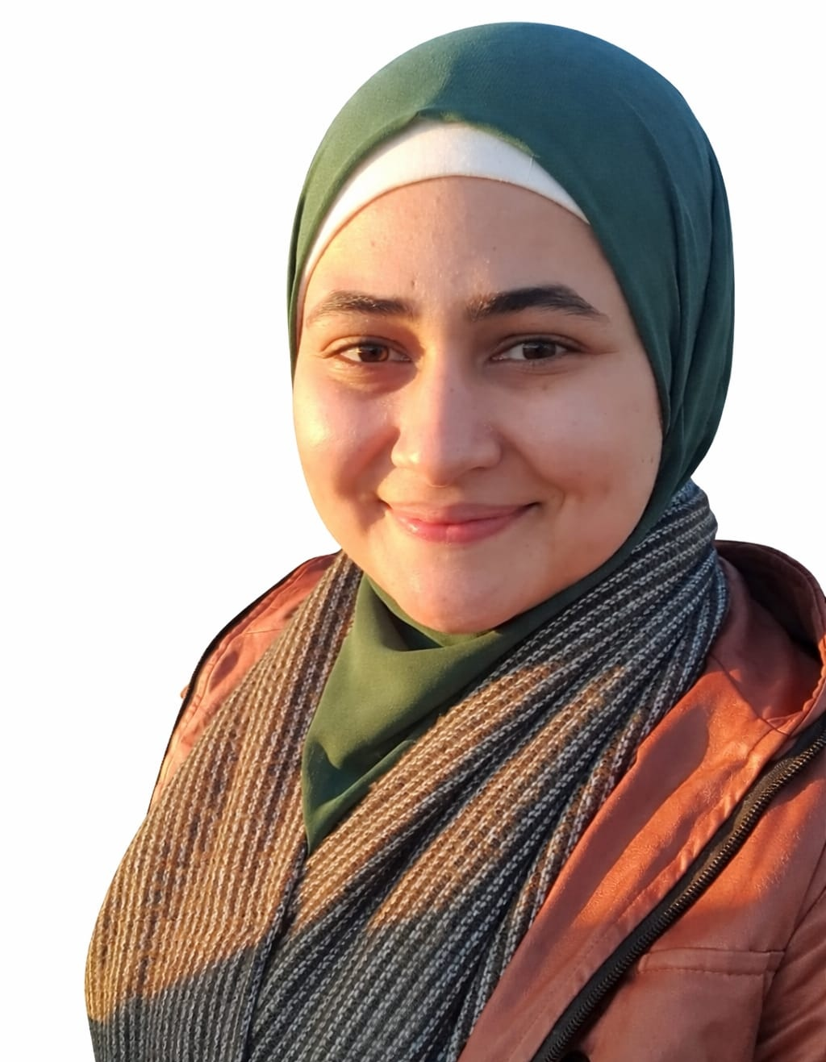
- Education:
2.A. Degree obtained;
Institution | Degree obtained | Year

2.B. Specialty;
General specialty. | Pathology
Specific specialty.

2.C. Language skills (Excellent, Very Good, Good or Basic);
Language | Reading | Speaking | Writing
Arabic. | Excellent | Excellent | Excellent
English. | Excellent | Good | Excellent
French.
Other (specify).

- Positions:
Tittle | Year | University/Institution

- Cooperation with local and international entities having website:
( جامعة – مؤسسة - وزارة – مركز بحثي – عضو هيئة تدريس – باحث - شركة – مصنع – الخ)
Name of local and international entity | Website
- Membership of professional bodies (List):

- Membership of institute (List):

- Distinction and Awards (List):

- Academic:
Courses at under graduate level;
1. Course name: | Clinical rounds;
2. Course name: | Lectures;
Courses at post graduate level;
1. Course name: | Clinical rounds;
2. Course name: | Lectures;
- Areas of research:

- PhD/M.Sc Supervision:
Title | PhD/M.Sc | Year completed / in progress
Evaluating Diagnostic Value of Trophoblast Cell Surface Antigen 2 (TROP-2) in Differentiating between Pleomorphic Adenoma and Mucoepidermoid Carcinoma in Parotid Gland Tumors"

- Grants for Projects:
Funding organization | Project title | Role | Year
- Committees:

- List of Publications:

14. Attended Workshops, Symposiums, and Conferences: "List name and year";

Name of Workshops, Symposiums, and Conferences | Year
13.1. | 2005

- Books published:

16. Positions:
 | Date | Organization | Country | Position
1
2
3

17. Activities in faculty/university/community service:
Name of Activity service | Year
- Teaching (Rounds and lectures).
- Clinical meeting.
- Making conferences.
- Medical Convoys.
- Workshops.
18. Consulting Experience (if any):

19. Additional information you would like to put on the website:

