Curriculum Vitae (C.V.)
- Personal data:
Name (Arabic) | يارا احمد إبراهيم قاسم البحيصي
Name (English) | Yara ahmed ibrahim kassem El_behasi
Department | Opthalmology
College | benha university
Academic degree | Master’s Degree in Ophthalmology
Office Address | Benha university
Mobile 1 | 01127552386
Home phone | 01127552386
Work phone | 01127552386
Fax
Email (university) | Kassem.yara245@gmail.com
Email (alternative)
Web site (if any)
Recent Photo (passport format) | 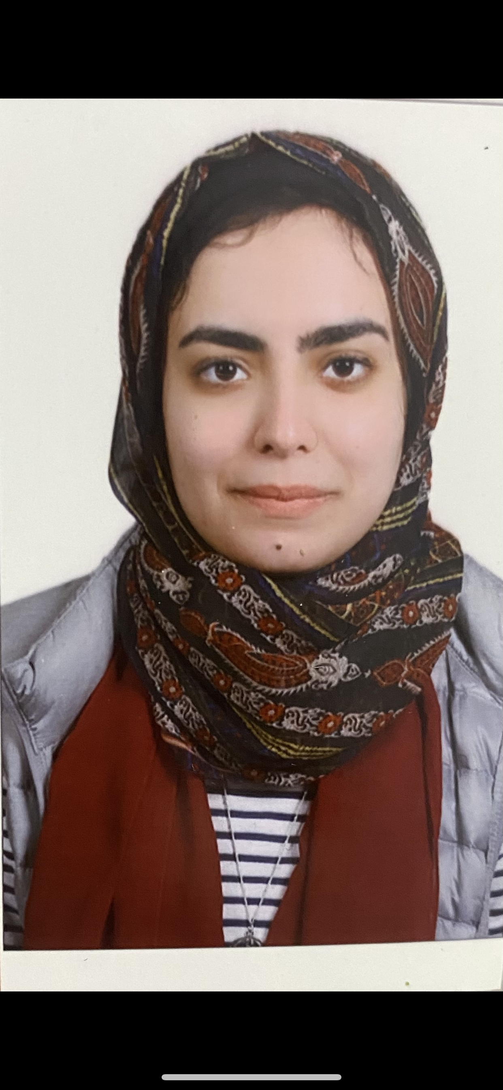
- Education:
2.A. Degree obtained;
Institution | Degree obtained | Year
Faculty of Medicine, benha University | Bachelor of Medicine and Surgery (M.B.B.Ch)
Faculty of Medicine, benha University | Master’s Degree in Ophthalmology

2.B. Specialty;
General specialty. | Opthalmology
Specific specialty. | Glaucoma

2.C. Language skills (Excellent, Very Good, Good or Basic);
Language | Reading | Speaking | Writing
Arabic. | Excellent | Excellent | Excellent
English. | Very Good | Good | Very Good
French.
Other (specify).

- Positions:
Tittle | Year | University/Institution
Assistant lecturer | 2024 | Benha university
- Cooperation with local and international entities having website:
( جامعة – مؤسسة - وزارة – مركز بحثي – عضو هيئة تدريس – باحث - شركة – مصنع – الخ)
Name of local and international entity | Website
- Membership of professional bodies (List):

- Membership of institute (List):

- Distinction and Awards (List):
- Academic:
Courses at under graduate level;
1. Course name: | Clinical rounds;
2. Course name: | Lectures;
Courses at post graduate level;
1. Course name: Physiology -Surgery | Clinical rounds;
2. Course name: | Lectures;
- Areas of research: pediatric ophthalmology .

- PhD/M.Sc Supervision:
Title | PhD/M.Sc | Year completed / in progress

- Grants for Projects:
Funding organization | Project title | Role | Year
- Committees:

- List of Publications:

14. Attended Workshops, Symposiums, and Conferences: "List name and year";

Name of Workshops, Symposiums, and Conferences | Year
13.1. | 2005

- Books published:

16. Positions:
 | Date | Organization | Country | Position
1
2
3

17. Activities in faculty/university/community service:
Name of Activity service | Year
- Teaching (Rounds and lectures).
- Clinical meeting.
- Making conferences.
- Medical Convoys.
- Workshops.
18. Consulting Experience (if any):

19. Additional information you would like to put on the website:

