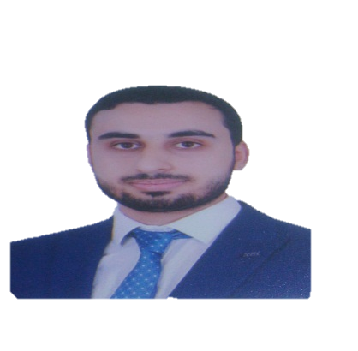
Ayman Mohammed Ali Elmaghrabi
Lecturer of ophthalmology- Benha University .

Contact informations
Address: Benha- Qalubia- Egypt. Postal code: 13741
Mobile: 010 118 156 96
Mail: ayman.almaghraby@fmed.bu.edu.eg
Ayman.almaghrabi2020@gmail.com
Languages
Arabic (mother tongue). English (excellent level). German (basics).
Skills
Computer skills. Scientific writing.
Soft skills. Learning skills.
Interests
Reading.
Education
Jan 2025 MD degree of ophthalmology, Benha University, Egypt.
April 2023: passed 1st part FRCO exam.
2017:2020 Master degree of ophthalmology, Benha University, Egypt.
2009:2015 Bachelor of medicine and surgery, Benha University, Egypt.
Work experience
Jan 2025 till now lecturer of ophthalmology, Benha university hospitals.
2020 :Jan 2025 Assistant lecturer of ophthalmology, Benha university hospitals.
Oct.: Dec. 2020 Ophthalmology specialist, Nasser general hospital, Shubra, Qalubia- Egypt.
2017: 2020 Ophthalmology resident, Benha University hospitals.
2016:2017 Internship trainee at Benha University hospitals.
Certifications
June 2022 Research international publishing certificate, Benha University.
Competitive project management certificate, Benha University.
October 2020 Question bank workshop certificate, Benha University.

March 2020 TOEFL (paper based test PBT) certificate, Benha University.
Scientific research methodology certificate, Benha University.
Scientific research ethics certificate, Benha University.
June 2011 ICDL certificate, Benha University & UNESCO.

wetlabs and workshops
Oct. 2024 Basic glaucoma surgery wetlab, Benha university.
27:28 oct. 2022 ozurdex implantation workshop, EGVRS RETINA ACADEMY.
Ocular investigation course, EGVRS RETINA ACADEMY.
June 2022 Corneal transplantation workshop, Benha university.
October 2020 Question bank workshop certificate, Benha University.
May 2015 Stem cells workshop (sources, isolation, culturing and its applications in medical field) at central laboratory in Benha university hospital.
April 2015 Inter personal skills (Vision, CV, Communication, Presentation and Interviewing skills and Action planning)
April 2015 Basics of research and international publications in addition to attending workshops about leadership skills and medical statistics.
Memberships
2015:2017 BSIRA, Benha Students Innovation and Research Association.
Conferences:

April 2024 Egyptian ophthalomolgy society (EOS) conference
March 2023 Speaker at Benha ophthalmology department conference: ( Understanding angle closure glaucoma)
27:28 Oct. 2022 Speaker at EGVRS RETINA ACADEMY case video competition: ( IOL exchange in late CBS: Defeat fear and save the only seeing eye).
21st March 2022 Glaucoma day meeting at Mansoura University ophthalmic centre.
10th :11th March 2022 1st international (9th annual) medical conference of Benha faculty of medicine.
10^{th:} 11th February 2022 5th international conference of EGSCOE.
23rd :24th September 2021 Alexandria Ophthalmology Summit (AOS), Raddison Blue Hotel, Alexandria.
Puplications
Elmaghrabi, A., El Habbak, A., Hamed, A., Salem, T., Awwad, M. 'Outcomes of Bent Ab Interno Needle Goniectomy Versus Incisional Goniotomy In Primary Open Angle Glaucoma Patients Undergoing Cataract Surgery', Benha Journal of Applied Sciences, 2024 9(10), pp. 61-76. doi: 10.21608/bjas.2024.325300.1512
Eleiwa TK, Elmaghrabi A, Helal HG, Abderlrahman SN,Elsheikh RH, Elhusseiny AM. Phylectenular keratoconjunctivitis in a patient with COVID 19 infection. Cornea. 2021 Jul 28. Doi:10.1097/ICO.0000000000002789.
Elmaghrabi A, Hegazy M, Daifalla A, Elsayed M. Correlation between peripapillary nerve fiber layer thickness and optic disc parameters in glaucoma patients using optical coherence tomography. Benha Journal OF Applied Sciences. 2020 oct. doi: 10.21608/BJAS.2020.135967

Volunteer work
2013:2016 BCP, Benha Charitable Pharmacy.
I shared in many medical convoys to areas of more needs and lastly:
22nd june 2022 medical convoy at Gamgara, Benha, Qalubia.
30th march 2022 medical convoy at Alshomot, Benha, Qalubia.
Honors And Awards
March 2017 Certificate of appreciation and award from Egyptian Medical Syndicate for being first over 330 medical students at Benha faculty of medicine during 6 study years (2009:2015).
March 2016 Certificate of appreciation from Benha university for my achievments during study years.
June 2014 The prize for first place in the scientific research competition in the college.
August 2009 Fourth place award after high school from Qalubia governorate.

