PREDICTING FACTORS OF THE OUTCOME OF CEREBRAL AVMs TREATED WITH ENDOVASCULAR EMBOLIZATION FOLLOWED BY GAMMA KNIFE RADIOSURGERY
Moataz A. Elawady¹, MD, Raef Hafiz², MD, Ahmed Alsirwy³, MD and Mohammed H. Eltantawy⁴, MD
- Assistant Professor of Neurosurgery, Benha University Hospital
- Professor of Neurosurgery, The International Medical Centre (IMC) Cairo- Egypt
- Professor of Intervention Radiology, Faculty of Medicine. Ain Shams University
- Assistant Professor of Neurosurgery, Benha University Hospital
ABSTRACT
BACKGROUND: Complete AVM obliteration could be achieved through microsurgery, endovascular techniques, or radiosurgery (focused radiation), in single or combined mannar. Each treatment option has associated risks and benefits
AIM OF THE STUDY: Our clinical study presents a prospective study of cerebral AVMs treated with endovascular embolization followed with gamma knife radiosurgery. We analyzed the clinical and angioarchitectural outcomes as well as the complications. Finally we tried to find out the predicting factors for the success of this combined modality
PATIENTS AND METHODS: Thirty nine patients with cerebral AVMs were treated endovascular embolization followed with gamma knife radiosurgery at The International Medical Centre in Cairo and studied analytically at THE Benha University Hospital from the beginning of January 2016 to the end of December 2021.
RESULTS: Factors that may predict the outcome clinically are:
    - Age
    - Pre interventional mRs.
    - Nidal configuration.
    - Spetzler-Martin grade.
    - AVM size

Factors that may predict the outcome radiologically are
- AVM size.
- Nidal configuration.
- Spetzler-Martin grade.
CONCLUSIONS: Endovascular embolization followed by stereotactic radiosurgery is considered a feasible management modality for most cases of grade III and Grade IV lesions with satisfactory rates of nidal obliteration.
KEYWORDS: cerebral AVM, endovascular embolization, Gamma knife radiosurgery
ABBREVIATIONS: AVM: Arteriovenous malformations
MR: Magnetic Resonance
DSA: Digital Substraction Angiography
S.M.: Spetzler- Martin
SRS: Stereotactic Radiosurgery

INTRODUCTION
Intracranial AVMs are relatively rare but can cause serious neurological symptoms up to death.^{1,2,3,4} Intracranial hemorrhage occurs at an average annual rate of 2 - 4%.⁵ At present, there are four major treatment options available for the patients with an intracranial AVM:^{5,6,7}
- Conservative approach with the risk of hemorrhage, occurrence of seizure or neurological deficit.^{8,9,10}
- Complete AVM obliteration through microsurgery, endovascular techniques, or radiosurgery (focused radiation), in single or combined mannar.^{11,12,13} Each treatment option has associated risks and benefits.^{14,15,16,17}
Reduction of the AVM nidus size by endovascular embolization can help total obliteration of the nidus by radiosurgery while minimizing the radiation dose and its hazards.^{18,19}
OBJECTIVES
Our clinical study presents a prospective study of cerebral AVMs treated with endovascular embolization followed with gamma knife radiosurgery. We analyzed the clinical and angioarchitectural outcomes as well as the complications. Finally we tried to find out the predicting factors for the success of this combined modality
PATIENTS AND METHODS
Patient Selection. Thirty nine patients with cerebral AVMs were treated endovascular embolization followed with gamma knife radiosurgery at The World Medical Centre in Cairo and studied analytically at The Benha University Hospital from the beginning of January 2016 to the end of December 2021.
Medical charts, operative reports, SRS records, and pre- and posttreatment imaging results including MR and digital subtraction angiography (DSA) were carefully reviewed to determine patient demographics, AVM characteristics on the Spetzler Martin grading system (Table 1), procedural complications, posttreatment cerebral hemorrhage, radiological AVM obliteration, and neurological outcome.
Clinically we depended upon the modified Rankin Scale to determine the degree of patient disability both before treatment and in each follow-up visit thereafter (Table 2)
Embolization Protocol. Embolization was performed with a liquid embolic agent Onyx. Embolization sessions were performed at 6-week intervals, as necessary, until the AVM nidus had been reduced to a volume of less than 10 cc. Targets were often selected that would treat and obliterate deeper portions of the nidus and those with large volume. Following Schwyzer et al.¹⁹ and zhao et al. ⁴ Our strategy with embolization was to achieve volume reduction and not flow reduction and ideally to target fixed portions of a nidus that would allow for a discrete nidus when targeting with SRS. Postembolization AVM size was calculated during SRS planning.
Stereotactic Radiosurgery Protocol. A stereotactic head frame was placed for all patients using local anesthesia supplemented by intravenous sedation. Next, biplane digital subtraction stereotactic angiography was performed followed by MR imaging . Volumetric 3D dose planning was performed using Leksell Gamma Plan software. SRS was performed with Leksell Gamma Knife units (Elekta AB). The median margin dose was 21Gy.
Follow-Up Evaluation. Radiological success was defined as complete AVM obliteration on DSA (total disappearance of the nidus and early draining veins) or, alternatively, on MR angiography (total disappearance of the nidus and flow voids) for patients with poor overall medical condition or for those refusing follow-up DSA. The median follow-up after SRS session was 38 months (range 16–36 months).
Statistical Analysis. Data are presented as median and range for continuous variables and as frequency for categorical variables. Univariate survival analysis was carried out to test covariates predictive of treatment obliteration. Factors predictive in univariate analysis (𝑃 < 0.20) were entered into a multivariate model. 𝑃 values of ≤0.05 were considered statistically significant. Statistical analysis was carried out with SPSS₁₆.
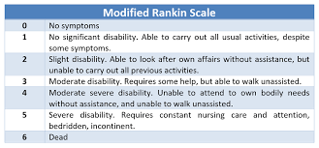
Table 1: modified Rankin scale²⁰
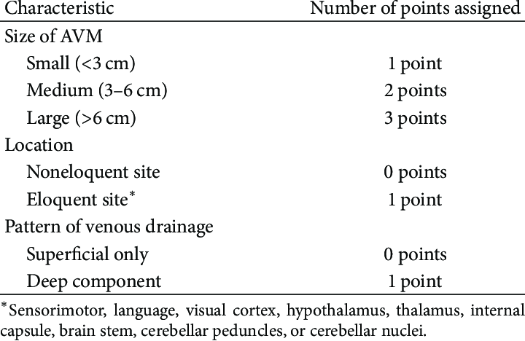
Table 2:Spetzler-Martin grading system¹⁹
RESULTS
Angioarchitectural AVM data:
15 (38.5%) were S.M grade III, 11 patients (28.2%) had S.M grade IV, 11 patients (28.2%)had S.M grade II, one patient with GI and one patient with grade V. AVM nidal size was less than 3 cm in 17 patients (43.6%), 3-6 cm in 20 patients (51.3%) and only two patients had nidal volume larger than 6cm. Both patterns of venous drainage were present; superficial in 16 patients 41% and deep in 10 patients 25.6%. Nidal volume ranged from 2.1 ml up to 25.5 ml with mean (10.71 ± 6.79).
Venous drainage
Superficial |  | 16 (41%)
Deep |  | 10 ( 25.6%)
Both |  | 13 (33.4%)
Nidal configuration
Compact |  | 23 ( 59 %)
Diffuse |  | 16 (41 %)
AVM Size
Small | 17 (43.6%)
Medium | 20 (51.3%)
Large | 2(5.1%)
S-M grade
I | 1(2.6%)
II | 11(28.2%)
III | 15(38.5%)
IV | 11(28.2%)
V | 1(2.6%)
Table (3): Angioarchitectural AVM data

The Main clinical presentation :
* Hemorrhage:
13 (33.3%) patients presented with intracranial hemorrhage (ICH).
* Seizures:
12 (30.8%) patients presented with seizures.
* Headache
8 (20.5%) patients presented with headache.
* Neurological deficit
5 (12.8%) patients presented with neurological deficit in the form of motor, sensory, and visual affection.
* Accidental finding
One (2.6%) patient was accidentally discovered

Procedure related complications:
Complications related to procedure occurred in 18 (46.2%) patients; most frequent complication was the motor deficit occurred in 10 (25.7%) patients ,followed by seizures occurred in 3 (7.8%) patients, hemorrhage in 2(5.1%),visual diminution in 2(5.1%) and only one patient (2.5%) experienced gait disturbance.

Variable | No complication | Complication | Total | P value
Age
Young | 15(80%) | 5(20 %) | 20(51.2 %) | 0.007**
adult | 6(31.5%) | 13(68.5 %) | 19(48.8%)
Pre mRS
0 | 8(100 %) | 0(0.0) | 8(20.5%) | <0.001***
1 | 11 (64.7%) | 6(35.3%) | 17(43.5%)
2 | 2(15.3%) | 11 (84.7%) | 13(33.3%)
3 | 0(0.0) | 1(100%) | 1( 2.7%)
S.M grade
1 | 1 (100%) | 0(0.0) | 1(2.6%) | 0.004**
2 | 9 (81.9 %) | 2(18.1%) | 11(28.2%)
3 | 10 (66.7 %) | 5 (33.3%) | 15(38.5%)
4 | 1(9%) | 10 (91%) | 11(28.2%)
5 | 0 | 1(100%) | 1(2.6%)
Size
Small | 15(88.2%) | 2(11.8%) | 17(43.6%) | <0.001***
Midium | 6(30%) | 14(70%) | 20(51.3%)
large | 0 | 2(100%) | 2(5.1%)
Table(4): Correlation between the rate of complications : and the age, the preprocedural neurological condition by (mRs), S-M grade and size of AVM nidus (***) means high statistical importance, (**) means statistical importance
Variable | No complication | Complication | Total | P value
Nidalconfig
compact | 18(78.2%) | 5(21.8 %) | 23(59 %) | <0.005**
diffuse | 3 (18.8%) | 13(81.2 %) | 16(41 %)
Venous drainage
superficial | 11(68.7) | 5(31.3%) | 16(41%) | 0.28
Deep | 4(40%) | 6 (60 %) | 10(25.6%)
Both | 6(46%) | 7 (54%) | 13(33.4%)
Clinical presentation
Seizures | 7(58.3 %) | 5(41.7%) | 12(30.8%) | 0.26
ICH | 4 (30.7%) | 9 (69.3%) | 13 (33.3%)
N deficit | 3(60 %) | 2(40%) | 5(12.8%)
H/A | 6(75%) | 2(25%) | 8(20.5%)
Accidental | 1(100%) | 0 | 1(2.6%)
Table (4):Correlation between the incidence of complications and the nidal configuration , the venous drainage and the clinical presentation (***) means high statistical importance, (**) means statistical importance
There were statistical significance between the rate of complications and the following factors :
- Age group.
- Pre interventional mRs.
- Nidal configuration.
- Spetzler-Martin grade.
- AVM size group.

The relation of post procedural complications was highly significant to the Pre interventional mRs and AVM size group.
While the rate of complications did not significantly correlate to:
- Venous drainage.
- The clinical presentation.

The Clinical outcome:
* Early clinical outcome
23 (59%) patients had no significant post endovascular deterioration in the neurological condition according to modified Rankin score (mRs). 16 (41%) patients had developed deterioration in the neurological condition.
This evaluation was done immediately after the endovascular embolization and during the following few hours especially when seizures occurred post interventional waiting till regaining baseline neurological condition.
* Late clinical outcome:
At long term follow up for the patients following them at 6,18, and 36 months post radio surgery no patient was found to develop new disabling neurological deficit additional to that of the pre procedural condition. Meanwhile, improvement of the neurological condition occurred in seven (18 %) patients of this group in the form of improvement of motor power grade and seizures control.
Neurological condition | Post  Embolization | Post  Radiosurgery
Improvement or the same | 23 (59%) | 30 (77%)
Deterioration | 16 (41 %) | 9 (23 %)
Total | 39(100%) | 39(100%)
Table (5): Comparison between early and late clinical condition.
* Late clinical outcome according to presenting symptoms:
* Hemorrhage:
13 (33.3%) patients presented with intracranial hemorrhage (ICH). Three patients experienced attack of minor ICH, occurred post embolization. They did not underwent SRS till complete resolution of the hematoma, for better demarcation of nidal radiation in gamma plan.
* Seizures:
12 (30.8%) patients presented with seizures, most of them were controlled postoperatively with proper medical treatment.
* Headache
8 (20.5%) patients presented with headache, most of them had significant improvement as regard severity and duration of headache attacks, only one patient needed treatment by analgesics.
* Neurological deficit
5 (12.8%) patients presented with neurological deficit in the form of motor, sensory, and visual affection, one of them showed improvement of motor power ,and another one showed improvement of vision.
* Accidental finding
The only one patient of this group who was accidentally discovered had no neurological deterioration.
Variable | The same mRs or improved | Deteriorated | Total | P value
Age
Young | 17(80%) | 3(20 %) | 20(51.2 %) | 0.22
Adult | 13(31.5%) | 6(68.5 %) | 19(48.8%)
S.M grade
1 | 1 (100%) | 0 | 1(2.6%) | 0.01*
2 | 10 (90.9 %) | 1(9.1%) | 11(28.2%)
3 | 14 (93.3 %) | 1 (6.7 %) | 15(38.5%)
4 | 5(45.5%) | 6 (54.5%) | 11(28.2%)
5 | 0 | 1(100%) | 1(2.6%)
Size
Small | 16(94.1%) | 1(5.9%) | 17(43.6%) | 0.003***
Midium | 14(70%) | 6(30%) | 20(51.3%)
Large | 0 | 2(100%) | 2(5.1%)
Nidal config
Diffuse | 9(56.3%) | 7(43.7%) | 16(41 %) | 0.011*
Compact | 21(91.3%) | 2(8.7%) | 23(59%)
Clinical presentation
Seizures | 8(66.7 %) | 4(33.3%) | 12(30.8%) | 0.82
ICH | 10 (77%) | 3 (23%) | 13 (33.3%)
N deficit | 4(80 %) | 1(20%) | 5(12.8%)
H/A | 7(87.5%) | 1(12.5%) | 8(20.5%)
Accidental | 1(100%) | 0 | 1(2.6%)
Table(6): Correlation between the clinical outcome : and the age, S-M grade, size of AVM nidus, nidal configuration and clinical presentation (***) means high statistical importance, (**) means moderate statistical importance (*) means low statistical importance
There were statistical significance between the clinical outcome and the following factors :
- AVM size.
- Nidal configuration.
- Spetzler-Martin grade.

The relation was strongly significant to the Pre interventional mRs and AVM size group.
While the clinical outcome did not significantly correlated to:
- Age.
- The clinical presentation.

Angioarchitectural outcome:
  - Early Radiological outcome:
Total nidal obliteration was achieved post procedural in only three (7.7%) patients of this group during immediate evaluation post endovascular embolization they experienced minor bleeding (ICH) due to partial recanalization. Subtotal nidal obliteration occurred in 25 (64%) of patients. The range in 5 (12.9%)of them was (90 - 95%), and also in 20 (51.2%) patients of them to lesser extent (75 - 90%) obliteration. While partial nidal obliteration (less than 75%)occurred in 11 (28.2%) of patients.
Late Radiological outcome:
The total nidal obliteration was achieved postprocedural in 22 (56.4%) patients of this group (via a follow up along 12, 24, 36 months post procedural). Subtotal nidal obliteration occurred in 11(28.2%) patients ranged from (70 % - 95%). Three (7.7%) patients had lesser extent of nidal obliteration (less than 70%). Only three patient (7.7%) had non fatal rebleeding.

Variable | Total oblitration | subtotal oblitration | Total | P value
Sizegroup
Small | 16(94.1%) | 1(5.9%) | 17(43.6%) | 0.004**
Midium | 5(25%) | 15(75%) | 20(51.2%)
Large | 1(50%) | 1(50%) | 2(5.2%)
S.M grade
1 | 1(100%) | 0 | 1(2.6%) | 0.002**
2 | 10(90.9%) | 1(9.1%) | 11(28.2%)
3 | 10(66.7%) | 5(33.3%) | 15(38.5%)
4 | 1(9.1%) | 10(90.9%) | 11(28.2%)
5 | 0 | 1(100%) | 1(2.6%)
Nidal configuration
Compact | 18(78.3%) | 5(21.7%) | 23(59%) | <0.001***
Diffuse | 4(25%) | 12(75%) | 16(41%)
Venous drainage
Superficial | 9(56.3%) | 7(43.7%) | 16(41%) | 0.37
Deep | 4(40%) | 6 (60 %) | 10(25.6%)
Both | 9(69.2%) | 4 (30.8%) | 13(33.4%)
Number of Embolization sessions
Once | 17(56.6%) | 13(43.4) | 30(77%) | 0.24
(1-3) sessions | 4(57%) | 3(43%) | 7(18%)
More than 3 | 1(50%) | 1(50%) | 2(5%)
Radiotherapeutic dose
12-15 gry | 12(52%) | 11(48%) | 23(59%) | 0.65
15-20 gry | 2(50%) | 2(50%) | 4(10.2%)
20-25 gry | 8(66.6%) | 4(33.4%) | 12(30.8%)

Table(7): Correlation between the rate of nidal oblitration and the S.M grade, venous drainage and nial size and configuration (***) means high statistical importance, (**) means moderate statistical importance

The percentage of nidal oblitration was statistically significant to the following factors:
- AVM size.
- Nidal configuration.
- Spetzler-Martin grade.

The relation was strongly significant to the AVM nidal configuration.

While the rate of nidal oblitration did not significantly correlated to the following:
- The venous drainage.
- Radiotherapeutic dose.
- The number of sessions of endovascular embolization.

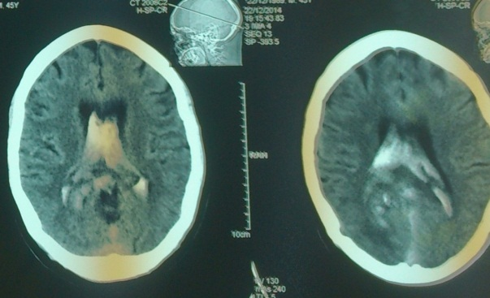

a
b 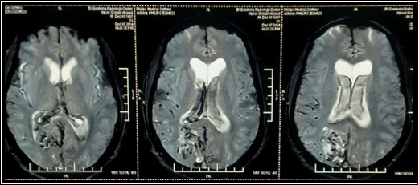
c 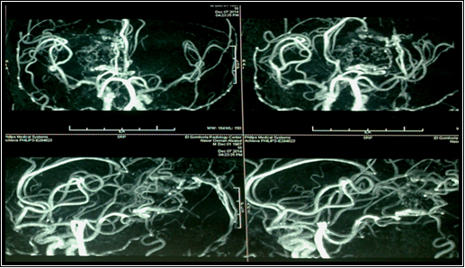
d

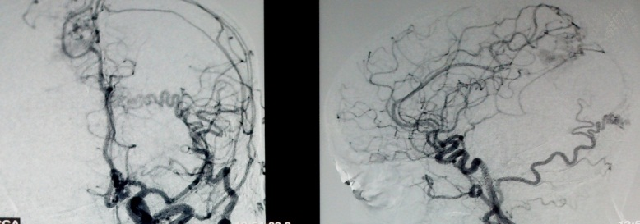

e
Fig.(1): (a) Non contrasted C.T brain : showing Rt occipital ICH with intraventricular extension, (b) T2WI axial MRI cuts: showing the AVM diffuse nidus. (c) 3D MR angiogram anteroposterior and lateral views showing the nidus (d) anteroposterior and lateral carotid angiograms; showing sizable residual of the AVM nidus suitable for SRS. (e) Follow up carotid angiogram (A-P &Lateral) views 36 months after stereotactic Gamma Knife; showing AVM nidal residual (arrow) for further management by another session of Gamma Knife.

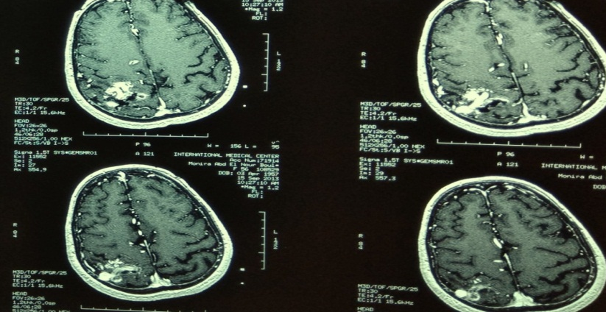

a

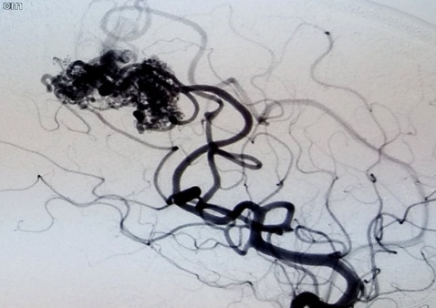
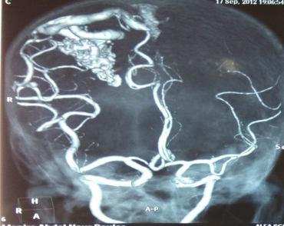
b 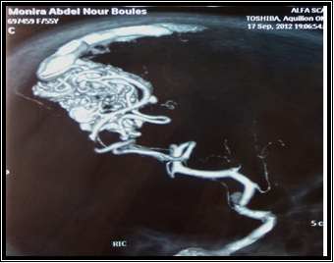

c

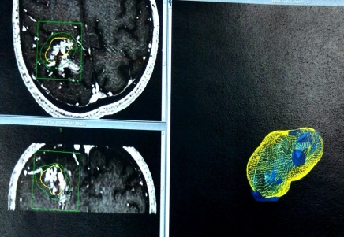

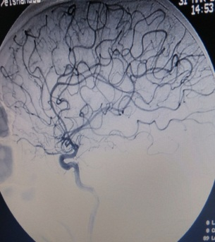

d

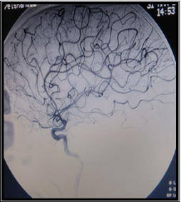
e

Fig.(2): (a) T1WI axial MRI brain with contrast, and (b) 3D MRA done showing RT posterior parietal AVM .The nidal diameter was 2.9 cm and the AVM was S-M grade II. (c) pre and postembolization lateral carotid angiograms (d) stereotactic radiosurgery with gamma knife for the residual nidus (e) A-P & lateral RT carotid angiograms : confirming total nidal obliteration.
DISCUSSION
Zhao et al., reported a frequency of 43% for the hemorrhagic presentation of AVMs. Headache was the second common clinical presentation and constituted 25%. Seizures occurred in 17% while neurological deficits occurred in 9%.⁴
In a comparative study to assess the role of preradiosurgical embolization Izawa et al. reported the results of AVM treatment with radiosurgery. No case of this series showed major complications or significant adverse effects met either after embolization or after radiosurgery. Long term morbidity rate was 7% in the cases that received preradiosurgical embolization and 9% in the cases that received sole radiosurgery. The delayed hemorrhagic risk was 0% and 3% in both groups respectively. In their study all outcome characteristics, namely, obliteration rate, long-term morbidity rate, incidence of delayed hemorrhage, and cyst formation, did not show statistically significant differences.⁵
Complete obliteration of AVM was attained in (67%) of cases in the study conducted by Izawa et al. It was obtained in average 2.9 ± 0.8 years after Gamma Knife radiosurgery. Partial obliteration (>50% reduction of the nidus volume) was noticed in 20% of cases, and less than 50% reduction of the nidus volume occurred in 13% of cases with an average follow-up of (4.2 ± 2.4 years). Complete obliteration of AVM had statistically significant associations with smaller nidus volume both at the time of diagnosis and before Stereotactic Gamma knife . The other evaluated factors ; patients' sex and age, presentation of the disease, time interval between embolization and radiosurgery, and marginal prescription isodose used did not reach the level of statistical significance ⁵

Kano et al., reported a total occlusion rate of (33.3%). Following 48 patients with supra tentorial AVM managed by stereotactic radiosurgery after embolization, accepted rates of partial nidal obliteration after embolization ranged from (15% - 80%) of nidal volume following the patients for 28 – 32 months after radiosurgery may explain the low percentage of total occlusion.20 (41.6%) patients achieved near total obliteration rate. 12 patients (25.1%) had partial nidal obliteration (50 – 80 %). The percentage of nidal obliteration was statistically significant to the Spetzler - Martin grade and nidal volume .¹¹

Total AVM nidal obliteration was also reported from Schwyzer et al. series as high as (72%) of patients following them in long-term periods mean 6.8 years ± 1.4 years ranged from 3.2 years to 8.5 years. This long-tem follow up made the higher rates of total obliteration is clearly logic due to insidious effect of the radiosurgery. The other (28 %) achieved accepted rates of obliteration ranged from (70-90%).¹⁹

CONCLUSIONS
Endovascular embolization followed by stereotactic radiosurgery is considered a feasible management modality for most cases of AVM lesions with satisfactory rates of nidal obliteration.
Factors that may predict the outcome clinically are:
    - Age
    - Pre interventional mRs.
    - Nidal configuration.
    - Spetzler-Martin grade.
    - AVM size

Factors that may predict the outcome radiologically are
- AVM size.
- Nidal configuration.
- Spetzler-Martin grade.
REFERENCES
- Ding D, Sheehan J, Starke R et al. (2015): Embolization of cerebral arteriovenous malformations with silk suture particles prior to stereotactic radiosurgery. J Clin Neurosci. (2015) 22:1643–9.
- Gross B and Du R (2013): Natural history of cerebral arteriovenous malformations: a meta-analysis. J Neurosurg. (2013) 118:437–43.
- Ilyas A, Chen C, Ding D et al.(2018): Radiationinduced changes after stereotactic radiosurgery for brain arteriovenous malformations: a systematic review and meta-analysis. Neurosurgery. (2018) 83:365–76.
- Zhao LB, Shim JH, Lee DG, et al. (2014): Two microcatheter technique for embolization of arteriovenous fistula with liquid embolic agent. Neurointervention. 2014;9(1):32-8.
- Izawa M, Chernov M, Hayashi M, et al., (2009): Combined management of intracranial arteriovenous malformations with embolization and gamma knife radiosurgery: comparative evaluation of the long-term results. Surg Neurol (2009) 71(1):43–52.
- Solomon R and Connolly E.(2017): Arteriovenous malformations of the brain. N Engl J Med. (2017) 376:1859–66.
- Spetzler RF and Martin NA(1986): A proposed grading system for arteriovenous malformations. Journal of Neurosurgery. 1986;65(4):476-483
- Knippen S, Putz F, Semrau S, et al. (2017): Predictors for occlusion of cerebral AVMs following radiation therapy: radiation dose and prior embolization, but not Spetzler-Martin grade. Strahlenther OnkolOrgan Deutschen Rontgengesellschaft. (2017) 193:185–91.
- Liew J, Yang W, Mashouf L, et al.(2020): Incidence of spontaneous obliteration in untreated brain arteriovenous malformations. Neurosurgery. (2020) 86:139–49.
- Yan D, Chen Y, Li Z, et al.(2021): Stereotactic Radiosurgery With vs. Without Prior Embolization for Brain Arteriovenous Malformations: A Propensity Score Matching Analysis.Front. Neurol. 12:752164.
- Kano H, Kondziolka D, Flickinger J, et al.(2012): Aneurysms increase the risk of rebleeding after stereotactic radiosurgery for hemorrhagic arteriovenous malformations. Stroke. (2012) 43:2586–91.
- Rivera R, Sordo J, Echeverria D (2017): Quantitative evaluation of arteriovenous malformationhemodynamic changes after endovascular treatment using parametric color coding: a case series study. Interv Neuroradiol. (2017)23:650–5.
- Russell D, Peck T, Ding D, et al. (2018): Stereotactic radiosurgery alone or combined with embolization for brain arteriovenous malformations: a systematic review and meta-analysis. J Neurosurg. (2018) 128:1338–48.
- Andrade-Souza Y, Ramani M, Beachey D et al. (2008): Liquid embolisation material reduces the delivered radiation dose: a physical experiment. Acta Neurochirurgica. (2008) 150:161–4; discussion
- Buell T, Ding D, Starke R et al. (2014): Embolization-induced angiogenesis in cerebral arteriovenous malformations. J Clin Neurosci. (2014)
- Daou B, Palmateer G, Thompson B, et al. (2020): Stereotactic radiosurgery for brain arteriovenous malformations: evaluation of obliteration and review of associated predictors. J Stroke Cerebrovasc Dis. (2020) 29:104863.
- van Swieten JC, Koudstaal PJ, Visser MC et al. (1988): J. Interobserver agreement for the assessment of handicap in stroke patients. Stroke. 1988;19:604–607.
- Chen C, Kearns K, Ding D, et al. (2019): Stereotactic radiosurgery for arteriovenous malformations of the basal ganglia and thalamus: an international multicenter study. J Neurosurg. (2019) 132:122–31.
- Schwyzer L, Yen CP, Evans A et al. (2012): Long-term Results of Gamma Knife Surgery for Partially Embolized Arteriovenous Malformations. Neurosurgery, Volume 71, Issue 6, December 2012, Pages 1139–1148
الملخص العربي
العوامل المنبئة بناتج التشوهات الشريانية الوريجية بالمخ الذين اجري لهم انصمام تداخلي متبوعا بسكينة جاما الاشعاعية
الخلفية العلمية: ان الغلق التام للتشوهات الشريانية الوريجية بالمخ ممكن عن طريق واحد او اكثر من الطرق الاتية: الجراحة الميكرسكوبية او السكينة الاشعاعية اوالطرق التداخلية
الهدف من الدراسة:محاولة تحديد العوامل المنبئة بالناتج الجراحي لمرضي التشوهات الشريانية الوريدية بالمخ الذين اجري لهم انصمام تداخلي متبوعا بسكينة جاما الاشعاعية
المرضي ووسائل الدراسة: دراسة مستقبلية علي كل المرضي الذين اجري لهم انصمام تداخلي متبوعا بسكينة جاما الاشعاعية
النتائج: اجريت هذه الطريقة علي 39 مريضا في المركز الطبي العالمي ودراسة النتائج وتحليلها احصائيا في مستشفي بنها الجامعي
الخلاصة: العوامل المنبئة سريريا هي سن المريض وحالته السريرية قبل التدخل علي معيار رانكن المعدل شكل التشوه وحجمه و درجته علي مقياس سبيتزلر مارتن بينما العوامل المنبئة تصويريا هي شكل التشوه وحجمه و درجته علي مقياس سبيتزلر مارتن

