AO Spine Injury Classification System; Application on Patients with Traumatic Thoracolumbar Spine Fractures Referred to Benha University Hospitals
M.M.Adawi, E.M.Zeiada, M.M.Wahdan, R.A.Teama, M.A.El-Awadi
Neurosurgery Dept., Faculty of Medicine, Benha Univ., Benha, Egypt

Abstract
Background: Thoracolumbar spine fractures are common injuries that can result in significant disability, deformity and neurological deficit. Injuries to thoracolumbar spine are usually the result of high-energy blunt trauma. Majority of thoracolumbar spine fractures occur due to falls from a height and motor vehicle injuries. The AO Spine thoracolumbar spine injury classification system separates fractures into three major types: type A—compression injuries; type B—tension band injuries and type C—translational injuries. Type A and B injuries are further subdivided into five and three subtypes, respectively. Next the neurologic status of the patient is evaluated and classified: N0—neurologically intact patient; N1—resolved transient neurological symptoms; N2—persistent radicular symptoms; N3—incomplete spinal cord injury or cauda equina injury; N4—complete spinal cord injury and NX— neurologic exam is unobtainable. Objectives: This study applied AO Spine classification system on patients with traumatic thoracolumbar spine fractures referred to Benha University Hospitals and clarifying its role on management, decision making and outcome of those patients. Methods: This prospective study was conducted to apply AO Spine injury classification system on patients with traumatic thoracolumbar spine fractures referred to Benha University Hospitals and was utilized to describe each spine fracture and to aid decision making and management of those patients. For one year between April 2021 and April 2022, 92 selected patients referred to Benha University Hospitals with acute traumatic thoracolumbar spine fractures were included in this study. Those patients were categorized into two groups according to their management either conservative or surgical based on AO Spine injury score. Results: The majority of the patients had no associated trauma to other systems rather than thoracolumbar fractures. L1 level was found to be the most common neurological level on admission detected in 36 cases (39.1%) then L2 level in 14 cases (15.2%). Back pain was the main presentation in thoracolumbar spine fractures that improved in clinical follow up. About 80% of patients were neurologically intact. A1 was the most common fracture description according to AO Spine classification on admission detected in 28 cases (30.4%) followed by A3 in 16 cases (17.4%) and B2 in 15 cases (16.3%). N0 was the most common neurological description according to AO Spine classification on admission detected in 59 cases (64.1%) followed by N3 in 16 cases (17.4%) and N2 in 10 cases (10.9%). The mean AO Spine Classification score was 4.2. About one third of patients (33.7%) were treated surgically and two thirds of patients (66.3%) were treated conservative according to AO Spine Classification Score. There was no change in decision making from conservative cases to surgical cases. The Mean of angle of kyphosis improved and decreased from 12.2 to 11.4 during follow up. About 95.5% of patients had minimal disability on 6th month follow up. Conclusion: The AO Spine thoracolumbar spine injury classification system represents a carefully developed, simple and comprehensive scheme that well classify thoracolumbar spine fractures and help surgeons to make good decision and management. Morphological description is critical to detect PLC affection and instability but neurological status is critical to determine the need for surgery.
Key words: thoracolumbar spine fractures, AO Spine injury classification, Neurological examination, X-Ray spine, ASIA scale, back pain, Cobb’s angle, Fusion.

Introduction
Thoracolumbar spine fractures are common injuries that can result in significant disability, deformity and neurological deficit. Thoracolumbar spine fractures form a significant portion of any spine surgeon’s practice. It is important to classify the injuries which may vary from minor transverse process fractures to unstable fracture dislocations in order to aid communication, plan management, anticipated outcome and prognosis.⁽¹⁾
A classification of injuries is necessary to develop a common language for treatment indication and outcomes and to develop a prognostic tool to guide treatment decision- making and predict the possibility of complications.⁽²⁾ Controversy surrounds the best way to classify thoracolumbar spine injuries that must be simple, reliable, comprehensive and reproducible as well as be validated by multiple observers.⁽³⁾
Till date, in spite of having several classification systems in practice, The AO Spine thoracolumbar spine injury classification system is probably the most comprehensive and management-oriented classification. ⁽¹⁾
This study applied the AO Spine classification system on patients with traumatic thoracolumbar spine fractures referred to Benha University Hospitals and clarified its role on management, decision making and outcome of those patients.

Patients and Methods
It would be known that it was the first time to apply AO Spine injury classification system in our neurosurgery department after long years of using Denis classification system. A prospective study was performed for a year at neuro-trauma unit of neurosurgery department, Benha University Hospitals and was utilized to achieve the aim of this study to describe each thoracolumbar spine fracture and to aid decision making and management of those patients. For one year between April 2021 and April 2022, 92 selected patients referred to Benha University Hospitals with acute traumatic thoracolumbar spine fractures were included in this study.

Inclusion criteria:
  - Acute traumatic vertebral fractures of thoracolumbar spine.
  - Both genders are included without privilege to age.

Exclusion criteria:
  - Pathological fractures; osteoporosis and malignancies.
  - Active infections: sepsis, osteomyelitis, discitis and epidural abcess.

Methods
All cases were submitted to careful history taking, general and neurological examinations and routine laboratory investigations. All cases had first aid management line according to ATLS; Advanced Trauma Life Support Protocol and then subjected to imaging investigations, plain X-ray thoracolumbar spine and CT thoracolumbar spine. Also, MRI thoracolumbar spine was done when indicated.

The following sheet was applied for the studied cases on admission as follow: Personal history:
Name, Age, Gender, Smoking, Previous disease.

History of present illness:
  - Type of trauma.
  - Associated trauma to other systems.
  - Back Pain or Radicular Pain.
  - Neurologic deficit after trauma.
  - Motor weakness.
  - Sensory impairment.
  - Sphincteric disturbances.

Examination:
General examination:
- To assess vital signs; Blood pressure, pulse and respiratory rate.
- To detect any associated injury as head injury, chest injury, bone injury or visceral injury.
- To assess fitness of the patient for surgery if needed.
Local examination: Back was examined for
- Tender spine or paravertebral muscles.
- Angulation deformity.
- Limited movements.
- Abrasions or contusions.

Neurological examination:
- To evaluate the neurological status regarding to AO Spine injury classification system.
- To evaluate the neurological functional level according to ASIA scale.

American spinal injury association impairment scale:
ASIA impairment scale is a standardized neurological examination used by the rehabilitation team to assess the sensory and motor levels which are affected by the spinal cord injury. The scale has five classification levels ranging from complete loss of neural function in the affected area to completely normal. Grades are A, B, C, D, and E. The results help the team set functional goals based on the neurological level of injury that is determined. ⁽⁴⁾

Verbal pain intensity scale for back pain:
This pain scale gave people a simple way to rate their pain intensity using a verbal or visual descriptor of their pain by asking the patient to select a word that best describes his back pain from the following words: ⁽⁵⁾
- No pain.
- Mild pain.
- Moderate pain.
- Severe pain.
- Very severe pain.
- Worst possible pain.

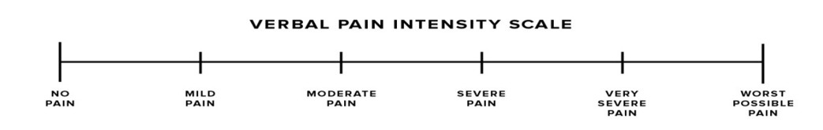
Fig. 1: Verbal Pain Intensity Scale ⁽⁵⁾

Recent AOSpine injury classification system:
The AO Spine Trauma Knowledge Forum, an international group of academic spine surgeons, was tasked to develop and validate a classification system incorporating both fracture morphology and clinical factors relevant for surgical decision making, such as the presence of neurological deficits. The goal of this effort was to develop a widely accepted, comprehensive yet simple classification system with clinically acceptable intra- and inter observer reliability to be used for clinical practice and research purposes. ⁽⁶⁾

This classification is based on the evaluation of 3 basic parameters:
- Morphologic classification of the fracture.
- Neurological status.
- Patient-specific modifiers.
Morphologic classification of the fracture: Injury morphology was classified as an A injury (compression), B injury (distraction), or C injury (translation). Type A fractures were graded in increasing severity as follows: A0 (simple or minor), A1 (compression), A2 (split or pincer), A3 (burst involving one endplate), and A4 (burst involving both endplates). Type B fractures included classic bony chance or monosegment bony tension band (B1), failure of the posterior tension band such as horizontal fracture lines through the posterior elements or evidence of posterior ligamentous disruption (B2) and hyperextension injuries (B3). Type C fractures/injuries demonstrate Translation / Displacement between cranial and caudal segments. If more than one injury was evident, the most severe injury was recorded.

Neurological status:
N0, neurologically intact patient; N1, resolved transient neurological symptoms; N2, persistent radicular symptoms; N3, incomplete spinal cord injury or cauda equina injury; N4, complete spinal cord injury and NX, neurologic exam is unobtainable.
Computed Tomographic Scan (CT): The new AO Spine classification is based on CT scan, an imaging tool widely available at most trauma centers in various countries. ⁽⁷⁾
Magnetic Resonance Imaging (MRI): It was done for patients with suspected neural injury and also used to evaluate soft tissue injuries including spinal cord, nerve roots, traumatic disc herniation and ligamentous injury.

AO Spine Injury Classification Score:
Patients with thoracolumbar spine injuries were categorized into two group according to their management either conservative or surgical based on:
- Scoring of AO Spine injury Classification.
- General condition of the patient.
For the AOSpine TL spine injury classification, associated point scores were determined. The points were assigned as follows: A0 (0-points), A1 (1-point), A2 (2- points), A3 (3-points), A4 (5-points), B1 (5-points), B2 (6-points), B3 (7-points), C (8-points), N0 (0-points), N1 (1-point), N2 (2-points), N3 (4-points), N4 (4-points), NX (3- points), M1 (1-point), and M2 (0-points). Under this classification, non-operative treatment is recommended for those with a score of 3-points or less, and operative treatment is recommended for those with scores of 5-points or more. Treatment of those with 4-points or 5-points can be treated either conservatively or operatively.

Statistical analysis:
The collected data were summarized in terms of mean ± Standard Deviation (SD) and range for quantitative data and frequency and percentage for qualitative data. Comparisons between the different study groups were carried out using the Chi-square test (χ2) and the Fisher Exact Test (FET) to compare proportions as appropriate. Paired sample t test (for parametric) or Wilcoxon signed rank sum test (for non-parametric) was used to assess changes in parameters over 2 occasions. Freidman's test was used to assess changes in parameters over more than two occasions. McNemar's test was used to determine if there are differences on a dichotomous dependent variable between two related groups. After the calculation of each of the test statistics, the corresponding distribution tables were consulted to get the ―P‖ (probability value). Statistical significance was accepted at P value <0.05. A P value <0.001 was considered highly significant while a P value >0.05 was considered non-significant.

Results:
Ninety-Two patients met the inclusion criteria. The mean age at injury was 32.6 years (range 13–71 years). Males were 54 & females were 38. The mechanism of injury was fall from height (n=55, 60%), motor vehicle accident (n=27, 29%), falling downstairs (n=7, 8%) and direct back trauma (n=3, 3%). 13 patients had associated trauma to other systems and 79 patients had no associated trauma to other systems. Utilizing the AOSpine TL spine injury classification, 67 patients had type A injuries, 22 patients had type B injuries and 3 patients had type C injuries; So, A1 was found to be the most common fracture description on admission in 28 cases followed by A3 in 16 cases, B2 in 15 cases and A2 in 13 cases with no cases with B3 injuries. The neurologic status of the patients was 59 (N0), 4 (N1), 10 (N2), 16 (N3), 1 (N4) and 2 (Nx). So, N0 was found to be the most common neurological description on admission. The mean AOSpine score was 4.2 (range 0–12) that 48 patients had score 0-3, 18 patients had score 4-5 and 26 patients had score 6-13. In the current study, 36 cases (39.1%) with L1 fracture, 14 cases (15.2%) with L2 fracture, 13 cases (14.1%) with L3 fracture and 11 cases (12%) with D12 fracture. So, the L1 level was found to be the most common affected neurological level on admission.

Table 1: Patients demographics, Injury, AOSpine characteristics and Fracture level (N=92)

Variable | Frequency
 | No. (%)
Age, years;  Mean ± SD Range  Sex  Male Female  Mechanism of injury: Falling from height Motor vehicle accident Falling downstairs Direct back trauma  Associated trauma to other systems:  Present Absent  AOSpine Injury Classification: A  A0 A1 A2 A3 A4  B  B1 B2 B3  C  Neurologic status N0  N1 N2 N3 N4  Nx  AOSpine Score: Mean ± SD Range Score:  0-3  4-5  6-13  Fracture Level: D3  D4 D5 D6 D9 D10 D11 D12 L1 L2 L3 L4  L5 | 32.62±13.8  13 – 71
54 (59%)
38 (41%)
 | 55 (60%)
 | 27 (29%)
 | 7 (8%)
 | 3 (3%)
 | 13 (14%)
 | 79 (86%)
67 (72.8%)
2 (2.2%)
28 (30.4%)
13 (14.1%)
16 (17.4%)
8 (8.7%)

22(23.9%)
7 (7.6%)
15(16.3%)
0 (0%)

3 (3.3%)

59 (64.1%)
4 (4.3%)
10 (10.9%)
16 (17.4%)
1 (1.1%)
2 (2.2%)

4.2 ± 3.3
0 – 12

48 (52.2%)
18 (19.6%)
26 (28.3%)

1 (1.1%)
1 (1.1%)
2 (2.2%)
1 (1.1%)
1 (1.1%)
2 (2.2%)
2 (2.2%)
11 (12%)
36 (39.1%)
14 (15.2%)
13 (14.1%)
7 (7.6%)
1 (1.1)

In the current study, 18 patients showed disturbed motor power, 8 patients had disturbed sensation on admission with 14 patients had disturbed sphincter control on admission while 78 patients had intact sphincter control. After 3 months of follow up, 7 patients regained their sphincter control and completely improved to increase to 85 patients with intact sphincter control but 5 patients (5.6%) still had disturbed sphincter control. After 6 months of follow up, another 3 patients regained their sphincter control and completely improved to increase to 88 patients (97.8%) with intact sphincter control but 2 patients (2.2%) still had disturbed sphincter control with statistically significant differences to sphincter control on admission and follow up at 3rd month and 6th month of discharge after application of AO Spine injury classification on studied patients (p <0.001).

Table 2: Clinical presentation of patients (N=92)
Variable | Frequency
Sphincter control Admission (n=92)  Intact Disturbed  3rd month Follow up (n=90)  Intact Disturbed  6th month Follow up (n=90)  Intact Disturbed  Motor power on admission (n=92)  Intact Disturbed  Sensation on admission (n=92)  Intact  Disturbed | No. (%)  78 (84.8%)  14 (15.2%)  85 (94.4%)  5 (5.6%)  88 (97.8%)  2 (2.2%)  74 (80.4%)  18 (19.6%)  84 (91.3%)  8 (8.7%)

Decision Making regarding AOSpine Score:
In the current study, 61 patients (66.3%) had a conservative management and 31 patients (33.7%) had a surgical management.

Table 3: Comparison between studied patients according to Decision Making regarding AO Spine Injury Score of AO Spine injury classification. (n=92)

Variable | Frequency (n=92)
 | No. (%)
Decision  Conservative | 61 (66.3%)
Surgical | 31 (33.7%)
In the current study, on admission, 3 patients (3.3%) complained mild pain, 31 patient (33.7%) complained moderate pain, 30 patients (32.6%) complained severe pain, 19 patients (20.7%) reported very severe pain and 9 patients (9.8%) had worst possible pain.
- With highly significant differences regarding back pain on discharge from admission (p2<0.001).
- With significant differences between admission and 3rd month and discharge and 3rd month (P3 <0.001, P4 <0.001).
- With significant differences between admission and 6th month (P5 <0.001).
- Comparison of repeated measures across all time points indicated highly statistically significant differences (P1 <0.001).

Table 4: Progression of back pain between studied patients on admission, discharge and follow up on 3rd month and 6th month of discharge. (n=92)
Back pain | Admission (n=92) | Discharge (n=90) * | follow up on 3rd month(n=90) * | follow up on 6th month (n=90) * | P value
 | No. (%) | No. (%) | No. (%) | No. (%) | P1<0.001  Post hoc test P2<0.001  P3<0.001  P4<0.001 P5<0.001
None | 0 (0%) | 1 (1.1%) | 38 (42.2%) | 65 (72.2%)
Mild | 3 (3.3%) | 25 (27.8%) | 50 (55.6%) | 24 (26.7%)
Moderate | 31 (33.7%) | 45 (50%) | 0 (0%) | 1 (1.1%)
Severe | 30 (32.6%) | 18 (20%) | 2 (2.2%) | 0 (0%)
Very severe | 19 (20.7%) | 1 (1.1%) | 0 (0%) | 0 (0%)
Worst possible pain | 9 (9.8%) | 0 (0%) | 0 (0%) | 0 (0%)

P1 progression of repeated measures across all time points using Friedman's test.
P2 progression of back pain on admission and discharge, using Wilcoxon signed ranks test.
P3 progression of back pain on discharge and follow up 3rd month.
P4 progression of back pain on admission and 3rd month.
P5 progression of back pain on admission and 6th month
American spinal injury association impairment scale (ASIA): In the current study, on admission, two patients (2.2%) were classified as ASIA A, one patient (1.1%) as ASIA B, 5 patients (5.4%) as ASIA C, 10 patients (10.9%) as ASIA D, 74 patients (80.4%) as ASIA E.
- With significant differences from admission (p3 = 0.025, P4= 0.025).
- Highly significant improvement was detected on 3rd month compared with admission scale (P5 = 0.002).
- Highly significant improvement was detected on 6th month compared with admission scale (P6 = 0.001).
- Comparison of repeated measures across all time points indicated highly statistically significant difference (P1 <0.001).

Table 5: Progression of neurological status between studied patients according to ASIA impairment scale on admission, discharge and follow up at 3rd and 6th months. (n=92)

ASIA  Score | Admission (n=92) | Discharge (n=90) * | Follow-up Follow-up Follow-up (6th P value (1st month) (3rd month) month)
 |  |  | (n=90)* | (n=90)* | (n=90)* | P1 < 0.001
 | No. (%) | No. (%) | No. (%) | No. (%) | No. (%) | Post hoc test
A | 2 (2.2%) | 0 (0%) | 0 (0%) | 0 (0%) | 0 (0%) | P2= 0.1
B | 1 (1.1%) | 1 (1.1%) | 1 (1.1%) | 0 (0%) | 0 (0%) | P3= 0.025
C | 5 (5.4%) | 3 (3.3%) | 2 (2.2%) | 1 (1.1%) | 1 (1.1%) | P4= 0.025
D 10 (10.9%) 11 (12%) 8 (8.7%) 8 (8.7%) 5 (5.6%) P5=0.002
E 74 (80.4%) 75 (81.5%) 79 (85.9%) 81 (88%) 84 (93.3%) P6=0.001
*Two patients died before discharge and not included in the follow up.
In the current study, the mean of Cobb’s angle on admission was 12.21 which decreased after 3 months to 11.49 and after 6 months to 11.43 (p <0.001). The current study showed that Application of AO Spine Injury Classification improved Cobb’s Angle of studied patients at 3rd and 6th months follow up that decreasing incidence of kyphosis between studied patients.

Table 6: Progression of Cobb’s angle between studied patients on admission and follow up at 3rd and 6th month.
Variable | On Admission (n=92) | After 3rd month (n=90) | After 6th month (n=90) | Test | P value
 | Mean ±SD (range) | Mean ±SD (range) | Mean ±SD (range)
Cobb’s Angle | 12.21 ± 5.14  (3-27) | 11.49 ± 3.87  (3-26) | 11.43 ± 3.61  (4-24) | F=12.563 | <0.001

Fig. 2: Bar chart shows change in Cobb’s angle on admission and after 3rd and 6th month follow up at both conservative and surgical groups.

Oswestry Disability Index:
The current study showed that Application of AO Spine Injury Classification improved quality of life of studied patients and their ability to return to work with significant differences between 3rd and 6th month regarding Oswestry Disability Index (P =0.006). On follow up at 3rd month in the current study, 81 patients (90%) with minimal disability, 5 patients (5.5%) with moderate disability, one patient (1.1%) with severe disability, two patients (2.2%) that were crippled and one patient (1.1%) that was bed bound. On follow up on 6th month significant improvement was detected where number of patients reported minimal disability increased to 85 patients (95.5%) and only 2 patients (2.2%) complained moderate disability, no patients (0%) reported severe disability, one patient (1.1%) was crippled and one patient (1.1%) was bed bound.

Table 7: Progression of quality of life between studied patients regarding Oswetry Disability Index at 3rd and 6th month follow up (n=90).
Oswetry Disability Index | at 3rd month (n=90) * | at 6th month (n=90)* | p
 | No. (%) | No. (%) | 0.006
0% to 20% (minimal disability) | 81 (90%) | 86 (95.5%)
21% - 40% (moderate disability) | 5 (5.5%) | 2 (2.2%)
41% - 60% (severe disability) | 1 (1.1%) | 0 (0%)
61% - 80% (Crippled) | 2 (2.2%) | 1 (1.1%)
81% - 100% (bed-bound or exaggerating symptoms) | 1(1.1%) | 1 (1.1%)
* Two patients died before discharge.
p= progression of quality of life regarding Oswetry Disability Index at 3rd and 6th month.
In the current study, 2 patients (2.2%) died before discharge (one died from traumatic head injury and other died from chest infection due to Covid 19), 2 patients (2.2%) developed wound infection at 1st month and 1 patient (1.1%) had fractured system at 2nd month and revision was done.

Fig. 3: Bar chart shows prognosis among the studied patients.
The current study showed that had 3 patients (9.7%) in the surgical group developed complications after surgery compared with no patients in the conservative group with statistically significant differences between both groups (p=0.015).
COMPLICATIONS
No Yes
CONSERVATIVE
SURGICAL

90.30%

100%

9.70%
0%

Fig. 4: Bar chart shows complications in conservative and surgical groups.

Case presentation:
Case No 1
Male patient, 35 years old presented to Neuro Trauma Unit, Benha University Hospitals after Road Traffic Accident with no associated trauma to other systems. On Examination, Patient complained:
  - Moderete low back pain as described by the patient.
  - No Neurological deficit as ASIA score E.

Initial management was done and advised to do CT thoracolumbar spine to assess any fracture spine that showed:
- Fracture Level: D12.
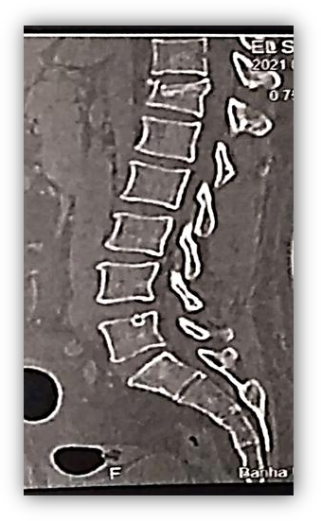
- Cobbs angle: 12.

Fig. 5: CT Lumbar spine sagittal view showed D12 Fracture, Type A1.

According to AO Spine Thoracolumbar spine Injury Classification:
  - Fracture Type: A1, wedge compression.
  - AO Spine Code: A1N0.
  - AO Spine Score: 1.
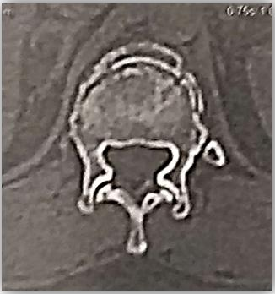
  - Decision: Conservative.

Fig. 6: CT Lumbar spine axial view showed D12 Fracture, Type A1.

On Follow up the patient at 3rd month of discharge:
  - No Neurological deficit detected as ASIA score E.
  - Low back pain disappeared as described (NO PAIN).
- Oswestry Disability index: Minimal disability
- Cobbs angle was constant: 12.
- No deformities or Complications were detected during follow up.
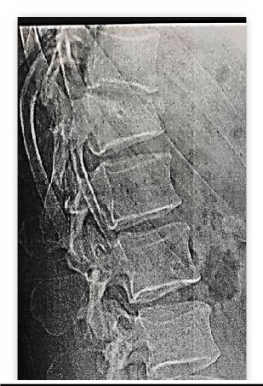

Fig. 7: X-Ray Lumbar spine, Lateral view follow up at 3rd month.

On Follow up the patient at 6th month of discharge:
  - No Neurological deficit detected as ASIA score E.
  - Low back pain disappeared as described (NO PAIN).
- Oswestry Disability index: Minimal disability
- Cobbs angle increased to 13.
- No deformities or Complications.

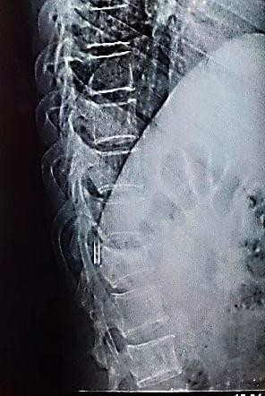

Fig. 8 : X-Ray Lumbar spine, Lateral view follow up at 6th month.

Case No 2
Male patient, 19 years old presented to Neuro Trauma Unit, Benha University Hospitals after falling from height with no associated trauma to other systems.
On Examination, Patient complained:
  - Very severe low back pain as described by the patient .
  - Neurological deficit as ASIA score C.

Initial management was done and advised to do CT thoracolumbar spine to assess any fracture spine that showed:
  - Fracture Level: L1
  - Cobbs angle: 22.

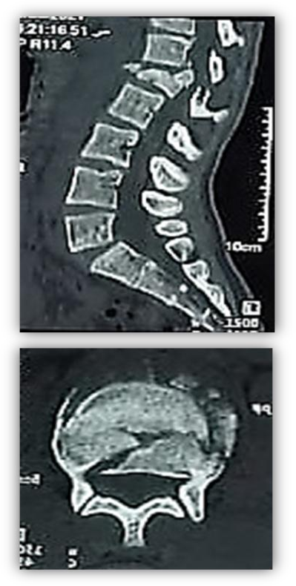

Fig. 9: CT Lumbar spine sagittal and axial views show L1 Fracture, Type B2 with A4 Component.

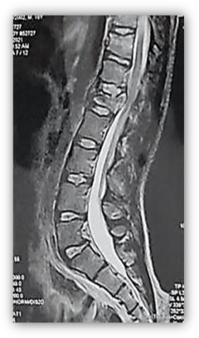
MRI Lumbar spine was done and showed PLC affection.
Fig. 10: MRI Lumbar spine T2WI Sagittal View shows L1 Fracture, Type B2 with A4 Component.

According to AO Spine Thoracolumbar spine Injury Classification:
  - Fracture Type: Complete Burst Fracture with Posterior Tension Band Affection, Type B2 with A4 Component.
  - AO Spine Code: B2N3 with A4 Component
  - AO Spine Score: 10 .
  - Decision: Surgery with Long segment fixation of the fractured level.
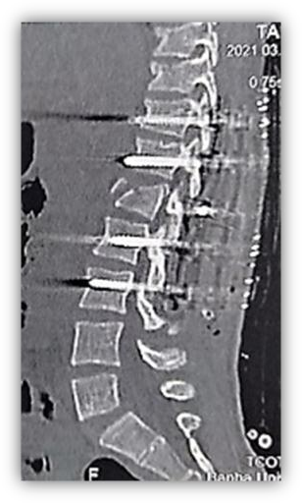

Fig. 11: Postoperative CT Lumbar spine, sagittal view shows Long segment fixation of the fractured level L1.

On Follow up the patient at 3rd month of discharge:
  - Neurological deficit improved to ASIA score D.
  - Low back pain decreased to Mild degree as described.
  - Oswestry Disability index: Moderate disability
  - Cobbs angle decreased to 12.
  - No deformities or No Complications
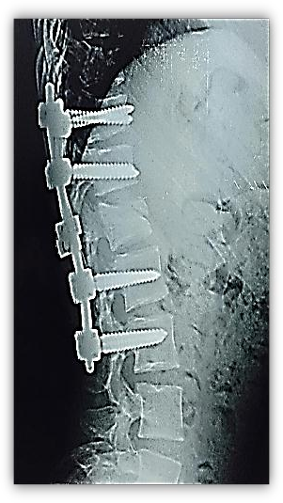

Fig. 12: X-Ray Lumbar spine, Lateral view follow up at 3rd month.

On Follow up the patient at 6th month of discharge:
- Neurological deficit improved to ASIA score D.
- Low back pain disappeared as described (NO PAIN).
- Oswestry Disability index: Moderate disability
- Cobbs angle was constant: 12.
- No deformities or Complications
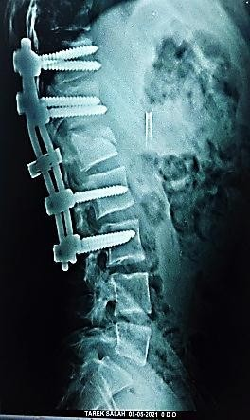

Fig. 13: X-Ray Lumbar spine, Lateral view follow up at 6th month.

CASE NO 3
Female patient, 37 years old presented to Neuro Trauma Unit, Benha University Hospitals after road traffic accident with associated trauma to chest as Right Lung Contusion.
On Examination, Patient complained:
  - Severe low back pain as described.
  - No Neurological deficit as ASIA score E.

Initial management was done and advised to do CT thoracolumbar spine to assess any fracture spine that showed:
  - Fracture Level: L1.
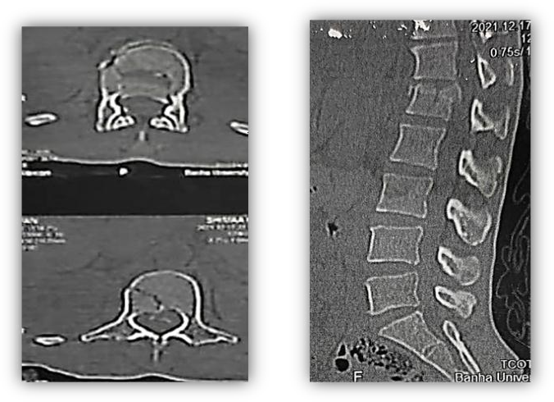
  - Cobbs angle: 15.
- Fig. 14: CT Lumbar spine sagittal and axial views showed L1 Fracture, Type A4.

MRI Lumbar spine was done and showed no affection to Posterior Ligamentous Complex.
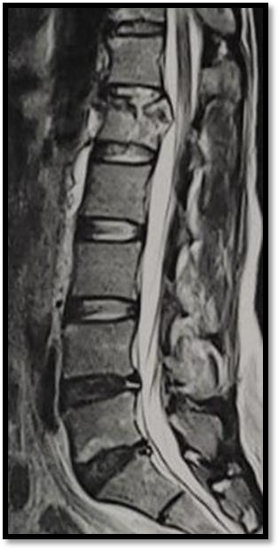
Fig. 15: MRI Lumbar spine T2WI Sagittal View shows L1 Fracture, Type A4.

According to AO Spine Thoracolumbar spine Injury Classification:
  - Fracture Type: A4, Complete Burst.
  - AO Spine Code: A4N0.
  - AO Spine Score: 5.
  - Decision: Conservative. This patient might be considered for surgery on Denis classification

On Follow up the patient on 3rd month of discharge:
  - No Neurological deficit detected as ASIA score E.
  - Low back pain disappeared as described (NO PAIN).
  - Oswestry Disability index: Minimal disability
  - Cobbs angle was constant: 15.
  - No deformities or Complications were detected during follow up.

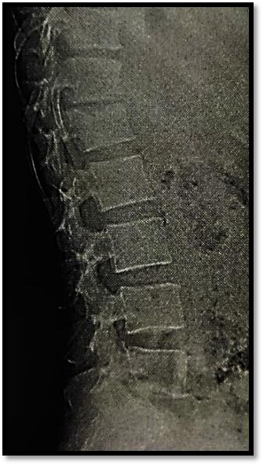

Fig. 16: X-Ray Lumbar spine, Lateral view follow up on 3rd month.

On Follow up the patient on 6th month of discharge:
- No Neurological deficit detected as ASIA score E.
- Low back pain disappeared as described (NO PAIN).
- Oswestry Disability index: Minimal disability
- Cobbs angle slightly increased to 16.
- No deformities or Complications.
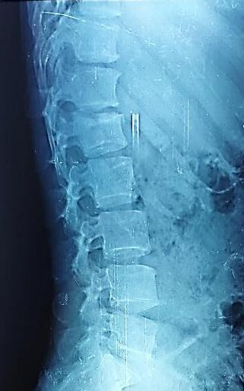

Fig. 17: X-Ray Lumbar spine, Lateral view follow up on 6th month.

Discussion
The current study revealed that less than one quarter of patients of thoracolumbar spine fractures had associated trauma to other systems and more than three quarters of those patients had no associated trauma. George M Ghobrial, ⁽⁸⁾ reported a retrospective review of thoracolumbar trauma found in 151 patients with about one third of patients had associated trauma to other systems as intra-abdominal injuries and head injuries that was similar to our study. Also, Heidari P et al., ⁽⁹⁾, reported that a total of 171 (27.6%) patients had associated non-spinal injuries. In study of Woltmann and Bühren et al., (10), a review of hospital admissions of patients with spinal injuries identified the presence of associated injuries in nearly half of the cases that differed with our study. Regarding fracture level of thoracolumbar spine fractures among studied patients, our current study reported that the L1 level was found to be the most common affected neurological level on admission detected in nearly half of cases followed by the L2, L3 and D12 levels in nearly third of cases. So, the study revealed that thoracolumbar region was the most common susceptible level to be injured as reported in about majority of studied cases. Muralidhar et al., ⁽¹¹⁾ was similar to the current study that the site of injury was at L1 level in nearly two thirds of studied cases followed by L2 & D12 levels in about one quarter of studied cases.
Yan et al., ⁽¹²⁾ revealed that L1 was the most common affected vertebra representing more than one third of studied cases. With the study reported by S Rajasekaran et al., ⁽¹³⁾ reported predominance of L1 fracture as among the thoracolumbar injuries, two thirds of cases affected the transitional zone (T11-L2).
In most studies, we noticed that L1 vertebra was the most common affected level as L1 is located at the center of transition zone between stiff kyphotic dorsal and mobile lordotic lumbar spine and also located between the coronal thoracic spine facets orientation and sagittal lumbar spine facets orientation. So, these conditions put L1 under maximum stress and make it more liable to be fractured.
Utilizing the AO Spine TL spine injury classification, Our Study reported that nearly three quarters of studied patients had type A injuries, less than one quarter of patients had type B injuries and few patients had type C injuries. So, Type A injuries were the most common injuries regarding AO Spine TL spine injury classification.
Vaccaro et al., ⁽⁷⁾ was similar to our study that reported that more than half of cases had type A injuries, about one quarter of cases had type B injuries and about less than quarter of cases had type C injuries that agreed with our study.
Barcelos et al., ⁽¹⁴⁾ differed with our study and reported that about one half of studied patients had type C injuries, one third of patients had type A injuries and few patients had type B injuries.
On Applying AO Spine TL spine injury classification, Our Study reported that about one third of cases was described as A1 injuries, followed by near quarter of cases for each B2, A3 and A2 injuries respectively. Also, our study reported few cases for A4, B1, C and A0 injuries respectively with no cases were reported as B3 injuries; About 25 patients had injuries classified as involving the PLC and the majority of studied cases was reported as type A injuries.
Urrutia J. et al., ⁽¹⁵⁾ differed with the current study and reported that one quarter of cases was described as B2 injuries followed by near one quarter of cases for type C injuries. But, more than tenth of cases for each A4, A3, A1 and B3 injuries respectively with few cases for A2, A0 and B1 injuries respectively.
Utilizing the AO Spine TL spine injury classification, Our Study reported that more than half of patients was described as N0 and near one quarter of patients was described N3 with few cases for N2, N1, Nx and N4 respectively.
So, N0 was found to be the most common neurological description on admission but N4 was found to be the least common neurological description on admission. Andrew Z et al., ⁽¹⁶⁾ reported that majority of cases were neurologically intact (N0) that was similar to our study.
The current study reported that the mean AO Spine score in our study was 4.2 and ranged 0-12 with about half of cases were ≤ 3 points and about one third of studied cases was >5 points, with about two thirds of studied cases were managed as conservative treatment and about one third of studied cases was managed as surgical intervention, with no change in decision making from conservative cases to surgical cases. Andrew Z et al., ⁽¹⁶⁾ differed with the current study as the mean AO Spine score was 8 and ranged 5– 12 and the majority of cases was >5 points. Thus, Most of cases were managed by surgical intervention.
Comparable to study of Hitchon et al., (17) 255 patients with thoracolumbar spine fractures were treated by their department. There were 172 patients with neurological deficit, all of whom were treated with decompression and instrumentation. The remaining 83 were neurologically intact and were given a trial of no operative treatment with gradual mobilization.
Our study showed that less than one quarter of studied cases complained disturbed motor power and disturbed sphincters control. Few cases had disturbed sensation on admission according to ASIA scale. Fernández et al., ⁽⁶⁾ was similar to our study and reported that there was an associated risk for accompanying spinal cord injury in about one quarter of studied cases.
Also, S Rajasekaran et al., ⁽¹³⁾ reported that neurological injury complicated around one third of the fractures that was similar with our study. George M. ⁽⁸⁾ reported that approximately half of the patients had neurologically deficits that differed with our study.
The current study reported that majority of studied patients had intact sphincter control while less than one quarter of studied patients, 14 patients, had disturbed sphincter control on admission. 12 patients of them were managed surgically and 2 patients were managed conservative with high statistically significant difference (p <0.001).
On follow up at 6th month, almost all those patients improved their sphincter disturbance, only one patient still complained sphincter disturbance for surgical group but conservative group had no patients with sphincter disturbance.
There were statistically significant differences to sphincter control on admission, follow up at 3rd month and 6th month of discharge after application of AO Spine injury classification on studied patients (p <0.001).
The study of Hitchon et al., ⁽¹⁷⁾ reported that according to sphincteric condition, majority of cases were sphincteric intact while less than one quarter of patients had sphincter disturbances that was similar with our study. Ling Wang et al., ⁽¹⁹⁾ reported few cases of sphincter disturbance that differed with the study.
In our study, about one third of patients complained moderate back pain and severe pain respectively, less than one quarter of patients reported very severe pain but few patients on admission complained mild pain and worst possible pain respectively. With highly significant differences regarding back pain on discharge from admission (p2<0.001). And with significant differences between admission and 6th month (P5 <0.001).
Diana D et al., ⁽²⁰⁾ reported that more than one third of patients with pain reported mild pain. Less than one third of patients complained moderate back pain. Also, more than one third of patients reported that they experienced severe pain. Few patients reported very severe pain or worst possible pain, with significant differences from admission and follow up.

The current study showed that distribution of back pain significantly differ in surgical group compared with conservative group on admission, discharge, 3rd month and 6th month (p1 <0.001, p2=0.001, p3=0.002, p4=0.005) that majority of patients of conservative group had no pain on follow up at 6th month but half of patients of surgical group had no pain on follow up at 6th month. Siebenga J. et al., ⁽²¹⁾ had a significant positive correlation as well as in conservative treated patients as in operative treated patients regarding back pain. The current study showed that Application of AO Spine Injury classification improved back pain of studied patients at 3rd and 6th months follow up according to Verbal Pain Intensity Scale.

The current study included 92 patients with traumatic thoracolumbar spine fractures that had more than three quarters of studied patients on admission as 74 patients (80.4%) as ASIA E that increased from 75 (81.5%) on discharge to 79 (85.9%) on 1st month and 81 (88%) on 3rd month and 84 (93.3%) on 6th month. With highly significant improvement was detected on 6th month compared with admission scale (P6 = 0.001). El Behairy H et al., ⁽²²⁾ was similar with the study and reported that patients with complete neurologic deficits ASIA A did not show any neurologic recovery. All ASIA B patients improved to ASIA C. Five ASIA C patients improved to ASIA E. The remaining five ASIA C patients improved to ASIA D. All ASIA D patients improved to ASIA B.
Costa F et al., ⁽²³⁾ ASIA grade was the dominant factor influencing the outcome, The study of Dobran M et al., ⁽²⁴⁾ was similar and reported that about three quarters of patients had improvement in neurologic function regarding ASIA grade at 1-year follow up with no patient worsened neurologically at 1 year follow up. Wang H et al., ⁽¹⁹⁾ reported that using the American Spinal Injury Association (ASIA) classification, 479 (15.3%) patients were classified as having ASIA A injuries and 913 (29.1%) patients as ASIA B, ASIA C, or ASIA D and 1750 (55.7%) patients ASIA E that was similar with our study. Patients with incomplete lesions (39.3%) improved 1 or more grades in ASIA classification during hospitalization. The current study showed that Application of AO Spine Injury classification improved neurological status of studied patients at 1st, 3rd and 6th months follow up according to ASIA impairment scale.

Wang et al., ⁽¹⁹⁾ reported that measurements of kyphosis were made in using the Cobb’s method, after producing lateral view radiographs of the segment affected. Our study reported that the mean of Cobb’s angle on admission was 12.21 which decreased after 3 months to 11.49 and after 6 months to 11.43 (p <0.001). Elsayed M. et al., (25) reported that angle of kyphosis was 17.22 ± 8. Hitchon et al., (17) reported that angle of kyphosis was (8±10). Our study reported that the mean Cobb’s Angle on admission for conservative group was 10.77 and for surgical group was 15.03 with significant differences between both groups on admission (p1<0.001) and the mean Cobb’s Angle regarding surgical group improved significantly across time but no significant differences across time regarding conservative group. The current study showed that Application of AO Spine Injury Classification improved Cobb’s Angle of studied surgical patients at 3rd and 6th months follow up while Cobb’s Angle of studied conservative patients became nearly constant at 3rd month follow up and slightly increased at 6th month follow up that referred decreasing incidence of kyphosis at both studied surgical and conservative groups.
In the majority of cases, accurate classification is possible with CT scan and/or plain radiographs. In the current scheme, MRI may be used to demonstrate disruption of the anterior or posterior tension band, demonstrating that an injury is at least a type B or may be used to demonstrate that the posterior hinge is disrupted, and that an extension-distraction injury is actually a type C. Vaccaro R. et al., ^{(7).}
Amjad F et al., ⁽²⁶⁾ reported that ODI was considered to be a gold standard self-reported outcome measure tool to evaluate quality of life and disability level after lumber radiculopathy.
The current study reported that majority of studied patients had minimal disability and few patients with moderate disability on follow up at 3rd month discharge. Azimi P et al., ⁽²⁷⁾ was similar with our study that it was hypothesized that patients with a higher score on the ODI would had a lower condition on the AO Spine injury classification.
The current study reported that comparison between 3rd and 6th month follow up showed that disability degree in the conservative group remained constant. However, the degree of disability significantly improved in the surgical group where no patients reported severe, crippled or bed bound disability (p=0.006) that there was high significant difference between conservative and surgical groups regarding distribution of patients in Oswetry Disability Index categories.
The study of Siebenga J et al., ⁽²⁸⁾ was similar and reported that the percentage of patients returning to their original jobs was found to be significantly higher in the operative treated group.
The current study showed that Application of AO Spine Injury classification improved quality of life and their ability to return to work at 3rd month and 6th month follow up according to Oswestry Disability Index.
The current study showed no change in decision making in both studied groups after application of AO Spine Injury classification.

Conclusion:
The AO Spine thoracolumbar spine injury classification system represents a carefully developed, simple but comprehensive scheme that well classify thoracolumbar spine fractures and help surgeons to make good decision and management. Both morphological description is critical to detect PLC affection and instability and neurological status is critical to determine the need for surgery.

Recommendations:
- Using CT spine is mandatory in all thoracolumbar spine fractures.
- Performance of MRI spine is not mandatory in all thoracolumbar spine fractures according to AO Spine Classification system.
- Type C injury would be treated surgically with CT fracture spine without waiting MRI spine.

References:
- Srinivasan P, A review of thoracolumbar spine fracture classification systems, Indian Spine J, 1(2):71-78, 2018.
- Max Aebi, Classification of thoracolumbar fractures and dislocations, Eur Spine J, 19(1): 2–7, 2010.
- Du J, Fan Y, Jun J et al., Decompression for Traumatic Thoracic/Thoracolumbar Incomplete Spinal Cord Injury: Application of AO Spine Injury Classification System to Identify the Timing of Operation, World Neurosurgery, 116: e867-e873, Aug 2018.
- Roberts T, Leonard R, Cepela D et al., Classifications In Brief: American Spinal Injury Association (ASIA) Impairment Scale, Clin Orthop Relat Res, 475(5): 1499–1504, May 2017.
- Hawker GA, et al. (2011). Measures of adult pain: Visual analog scale for pain (VAS pain), numeric rating scale for pain (NRS pain), McGill pain questionnaire (MPQ), et al.
- Fernandes A, Lendner M, Ferreira M, Vaccaro R et al. Fundamentals of Neurosurgery, A Guide for Clinicians and Medical Students, Spinal Trauma. The registered company Springer Nature, Switzerland AG. 5: 81-110, 2019.
- Vaccaro A,Alexander R, Bellabarb C, Dvorak M, Kepler K, Oner C, Schnake K, et al. AO Spine Thoracolumbar Spine Injury Classiﬁcation System: fracture description, neurological status, and key modifiers. SPINE. 38 (23):2028 – 2037, 2013.
- George M Ghobrial, Thoracolumbar Spine Trauma: Review of The Evidence, Journal of Neurosurgical Sciences 57(2):115-122, 2013.
- Heidari P, Zarei M, Rasouli M et al., Spinal Fractures Resulting From Traumatic Injuries, Chin J Traumatol, 13(1):3-9, 2010.
- Woltmann A and Bühren V, Injuries to the Thoracic and Lumbar Spine, Der Unfallchirurg, 106(1): 55-68, 2003.
- Muralidhar B, Hegde D and Hussain P, Management of Unstable Thoracolumbar Spinal Fractures by Pedicle Screws and Rods Fixation, J Clin Diagn Res, 8(2): 121–123, 2014.
- Yan B , Wei Qi, Xiang Z et al., Finite Element Study of the Mechanical Response in Spinal Cord during the Thoracolumbar Burst Fracture , PLOS ONE, 7 ( 9): e41397, 2012.
- Rajasekaran S, Prasad A, Mugesh R. Management of thoracolumbar spine trauma: An overview. Indian J Ortho. 49(1): 72–82, 2015.
- Barcelos ACES, Joaquim AF, Botelho RV. Reliability of the evaluation of PLC injury in thoracolumbar spine trauma with the use of computed tomography scan. European Spine Journal. 2016;25(4):1135–43.
- Urrutia J, Zamora T, Yurac R et al., An independent interobserver reliability and intraobserver reproducibility evaluation of the new AOSpine Thoracolumbar Spine Injury Classification System, Spine, 40(1): E54-E58, 2015.
- Andrew Z, Miller P, Michael P et al., The Reliability of the AOSpine Thoracolumbar Classification System in Children: Results of a Multicenter Study, J Pediatr Orthop, 40(5): e352-e356, 2020.
- Hitchon P, Abode-Iyamah K, Dahdaleh N et al. (2016): Nonoperative management in neurologically 5) 1185 intact thoracolumbar burst fractures: clinical and radiographic outcomes. Spine, 41(6): 483-489. 30.
- Fernández-de Thomas RJ, De Jesus O. Thoracolumbar Spine Fracture. [Updated 2021 Aug 30]. In: StatPearls [Internet]. Treasure Island (FL): StatPearls Publishing; 2022 Jan-. Available from: https://www.ncbi.nlm.nih.gov/books/NB K562204/
- Wang H, Zhang Y et al., Epidemiology of Traumatic Spinal Fractures: Experience From Medical University– Affiliated Hospitals in Chongqing, China, 2001–2010, Journal of Neurosurgery: Spine, 17(5): 459–468, 2012z
- Diana D, Cardenas DD, Jensen MP et al., Treatments for chronic pain in persons with spinal cord injury: A survey study. J Spinal Cord Med. 2006;29(2):109-17.
- Siebenga J, Leferink M, Segers M et al., A Prospective Cohort Study Comparing The VAS Spine Score and Roland–Morris Disability Questionnaire in Patients with a Type A Traumatic Thoracolumbar Spinal Fracture, European Spine Journal, 17: 1096–1100, 2008.
- El Behairy F, Abdelaziz A, Saleh A et al., Short-Segment Fixation of Thoracolumbar Fractures with Incorporated Screws at the Level of Fracture, Orthop Surg, 12(1):170-176, 2020.
- Costa F, Sharif S, Shaikh Y et al., Clinical and Radiological Factors Affecting Thoracolumbar Fractures Outcome: WFNS Spine Committee Recommendations, Neurospine, 18(4):693-703, 2021.
- Dobran M, Iacoangeli M, Colasanti R et al., Neurological Outcome in A Series of 58 Patients Operated for Traumatic Thoracolumbar Spinal Cord Injuries, Surg Neurol Int, 5(7): S329– S332, 2014.
- Elsayed M, Kelany A, Selim M. Thoracolumbar Fractures in Adolescent Patients: Epidemiological, Clinical, Radiological Characteristics and Recent Methods of Management. The Egyptian Journal of Hospital Medicine. 81(1): 1178-1185, 2020.
- Amjad F, Mohseni-Bandpei MA, Gilani SA, Ahmad A, Waqas M, Hanif A. Urdu version of Oswestry disability index; a reliability and validity study. BMC Musculoskelet Disord. 2021 Mar 29;22(1):311.
- Azimi P, Mohammadi HR, Azhari S, Alizadeh P, Montazeri A. The AOSpine thoracolumbar spine injury classification system: A reliability and agreement study. Asian J Neurosurg. 2015 Oct- Dec;10(4):282-5.
- Siebenga J, Vincent J, Michiel S et al., Treatment of Traumatic Thoracolumbar Spine Fractures: A Multicenter Prospective Randomized Study of Operative Versus Nonsurgical Treatment, Spine, 31(25): 2881-2890, 2006.

