Online ISSN : 2314-8969 Print ISSN: 2314-8950
www.esj.journals.ekb.eg
EGTheYPTIAN
DOI: 10.21608/esj.2020.21585.1117
EgySpineJ 33:45-53, 2020
CLINICAL ARTICLE
Journal
SPINE

Dynamic Cervical Implants (DCI) versus Anterior Cervical Discectomy and Fusion (ACDF) in Single-Level Cervical Disc Disease (CDD): Clinical and Radiographic Outcome
Moataz A Elawady, MD., Ramy Taema, MD., Mahmoud M Wahdan, MD.

Neurosurgery Department, Faculty of Medicine, Benha University, Benha, Egypt.
ABSTRACT
Background Data: In spite of being successful, anterior cervical discectomy and fusion ACDF has some complications, among them, pseudoarthrosis, implant failure, and adjacent level disease. Dynamic Cervical Implants (DCI) are motion-preserving implants started to take part in treating cervical spondylotic disease with promising results.
Purpose: To compare the clinical and radiographic outcomes of ACDF versus DCI in patients with degenerative cervical radiculo- and/or myelopathy.
Study Design: A prospective randomized controlled study.
Patients and Methods: Forty patients with cervical spondylotic radiculo- and/or myelopathy were recruited for this study. They were 21 males and 19 females with mean age of 458.9± years. They were randomly allocated for either the ACDF group including 20 patients undergoing ACDF using PEEK cages or the DCI group including 20 patients using DCI. Clinical outcome parameters were brachialgia VAS and NDI, and radiological outcome parameters were fusion rate, adjacent level changes, and segmental mobility.
Results: The mean follow-up was 204± months. The mean VAS of brachialgia decreased from 8.7 preoperatively to 6.6 postoperatively in ACDF group, while it decreased from 8.8 to 6.4 in DCI with no significant differences in both groups. The mean NDI improved from 24.7±1.6 to 16.2±1.8 in ACDF group and from 23.9±2.1 to 15.8±2.0 in DCI group, with no significant difference in both groups. Fusin rate was 100% in ACDF group. Radiologically, adjacent level changes were reported in 5 (25%) patients in ACDF group, while these changes were only observed in 1 patient (5%) of the DCI group. Segmental mobility was preserved in all patients in the DCI group but was lost in 3 patients at final follow-up visit. Conclusion: Although clinical outcomes of both ACDF and DCI groups were not significantly different at final follow-up, radiographic parameters were relatively better in DCI group compared to ACDF group including segmental mobility preservation and adjacent level changes. (2019ESJ198)

Keywords: ACDF; DCI; Cervical spondylosis; Radiculopathy; Myelopathy.

Address correspondence and reprint requests: Mahmoud M Wahdan, MD. Neurosurgery Department, Faculty of Medicine, Benha University, Benha, Egypt. E-mail: drwahdan@hotmail.com
Submitted: November 18th, 2019. Accepted: December 12th, 2019. Published: January, 2020. | The article does not contain information about medical device(s)/drug(s). No funds were received in support of this work.  The authors report no conflict of interest.

INTRODUCTION
Anterior cervical discectomy and fusion (ACDF) is considered to be a highly successful surgical technique for cervical spondylosis associated with brachialgia and/or myelopathy.1,2,4 Nonunion accounts for more than two-thirds of failures in ACDF surgeries and iliac bone graft morbidity is also reported in about one-third of multilevel fusion operations.18,21 There are many types of cages used to avoid the complications associated with iliac bone grafting.16,19,20 These problems include persistent donor-site pain, infection, hematoma formation, iliac crest fracture, and meralgia parasthetica.6,21
However, in spite of being successful for many years, ACDF has its own complications in the form of nonunion, implant failure, and adjacent level disease which occurs due to the excessive motion observed at the levels immediately above and/or below the index level.8,13,17,18 It has been proven to provide clinical stability after decompression.5 However, although it achieves long-term success, ACDF is not without complications as there have been reports of pseudoarthrosis, implant failure, and adjacent level disease which occurs due to the significant amount of increased motion observed at the levels immediately above and below the fusion. However, greater compensation occurred at the inferior segments compared to the superior segments for the lower level fusions.8,13,17,18,22
DCI is a titanium implant, originally invented in 2002 by Dr. Guy Matgé, Luxembourg. It was introduced in clinical use, in 2004. The design was modified to better accommodate the normal disc anatomy. The DCI implant with its motion preservation characters is unique implant. It stabilizes the cervical spine while still offering a limited, controlled flexion and extension movements allowing the spine to dynamically perform its function. It also acts as a shock absorber, preventing accelerated degeneration in
adjacent segments. Thus, the DCI implant aims at combining the advantages of the gold standard “fusion” with a motion preservation philosophy.15 The objective of this study is to compare the clinical and radiographic outcomes of ACDF versus DCI in patients with degenerative cervical radiculo- and/or myelopathy operated upon at Benha University Hospital.
PATIENTS AND METHODS
This is a prospective randomized controlled study comparing between ACDF and DCI in treating chronic cervical spondylotic radiculo- and/or myelopathy. We recruited 40 patients (21 males and 19 females) with mean age of 458.9± (range, 38–53) years. All patients presented with cervical spondylotic radiculo- and/or myelopathy and were admitted to the Neurosurgery Department, Benha University Hospital, between January 2015 and May 2019. All patients received conservative therapy for at least 3 months before being scheduled for surgery. Patients were randomly divided into two groups according to their hospital admission number sequences. ACDF group included 20 patients (11 males/9 females) with mean age of 44±9.7 (range, 38–50) years; DCI group included 20 patients (10 males/10 females) with mean age of 46±8.5 (range, 39–53 y) years.
We included all patients with single-level MRI documented cervical disc disease who presented with cervical radiculo- and/or myelopathy and failed adequate conservative treatment. Patients with multiple cervical disc disease, osteoporosis, cervical canal stenosis, OPLL, or other systemic or local pathology were excluded from this study. Preoperative clinical evaluation comprised of the Visual Analogue Score (VAS) of arm pain and the Neck Disability Index (NDI). Radiographic workup included plain radiographs in the anteroposterior and lateral projections and Magnetic Resonance Imaging (MRI).

Surgical Procedure
The patients underwent the procedure under general anesthesia (I.V. and inhalational anesthesia) in supine position with the neck slightly extended. All patients underwent operation utilizing the anterior Smith-Robinson approach from the right side. Surgical procedures were uniformly conducted in both groups including skin incision, subcutaneous dissection, platysma muscle splitting, and strap muscle dissection. The target level was determined using fluoroscopy and disc material was removed and cortical endplates were partially curetted, opening the posterior longitudinal ligament. Following this, in the ACDF group, a suitable sized PEEK cage (Orthofix Inc., Lewisville, TX) was inserted. The hollow of the cage was loaded with Demineralized Bone Matrix (DBM); in the DCI group, a DCI (Z-Brace Dynamic Fusion CageTM, Baui Biotech Co., Ltd., Taiwan) titanium containing material was inserted. The implant position was checked with fluoroscopy and meticulous hemostasis and wound closure in layers without drain were performed.
Postoperatively, all patients wore a rigid collar for 6weeks and then started a physiotherapy course, regaining their normal activity gradually.
At follow-up, patients were followed at the outpatients’ clinic and evaluated clinically and radiographically at 6-week and then at 3-month intervals. At each visit, they submitted to neurological evaluations (motor, sensory, or reflex) and reported the VAS of the arm pain and NDI. They were also submitted to plain radiographs (flexion/extension, AP, and lateral views) reporting signs of fusion, preserved segmental motion, and adjacent level changes, including disc space narrowing and worsening of spondylotic
changes. Fusion was assessed by bony bridging between the implant and the facing endplates based on plain radiographs. Both endplates were required to be incorporated in order for the subject to be judged as fused. Segmental mobility was assessed using Cobb’s angle measurement.
RESULTS
The mean follow-up period was 21 ±3 months (range 18–24). The operated levels distributed homogenously in both groups are depicted on Chart 1. At the last follow-up, the mean VAS of brachialgia decreased from 8.7±1.1 to 6.6±0.8 in ACDF group, while it decreased from 8.8±1.2 to 6.4±1.0 in DCI group. The NDI improved from 24.7±1.6 to 16.2±1.8 in ACDF group, while in the DCI group it improved from 23.9±2.1 to 15.8±2.0, depicting significant improvement in both parameters in both patients’ groups (Table 1). Fusion occurred in all cases of ACDF. Five out of 20 patients (25%) had radiological changes of aggravated spondylosis in the index level in ACDF group, while in DCI group we had only 1 (5%) which may be of clinical importance (Table 2). The mobility of the operated segments was preserved in 17 out of total 20 patients in the DCI group. Loss of mobility across the operated segment was reported in 3 patients; this was due to excessive calcification over the implant in 2 patients and due to improper positioning of the implant in another patient. There was no reported DCI migration or sinking in any of our patients. In 1 patient, there was a malpositioned implant slightly deviated to one side with no other sequela. There were no reported significant morbidity or mortality throughout this study.

Table 1. Epidemiological data and clinical outcome parameters.

Parameter |  | ACDF | DCI
Number of patients |  | 20 | 20
Mean age (years) |  | 44±9.7 (38–50) | 46±8.5 (39–53)
Male/female |  | 11/9 | 10/10
Clinical diagnosis | Radiculopathy | 17 | 16
 | Radiculomyelopathy | 3 | 4
Follow-up/months |  | 20±4 | 21±3
Mean VAS (brachialgia) | Preoperative | 8.7±1.1 (6–9) | 8.8±1.2 (7–9)
 | Postoperative | 6.6±0.8 (4–7) | 6.4±1.0 (5–7)
Mean NDI | Preoperative | 24.7±1.6 (20–28) | 23.9±2.1 (20–27)
 | Postoperative | 16.2±1.8(10–18) | 15.8±2.0 (10–20)

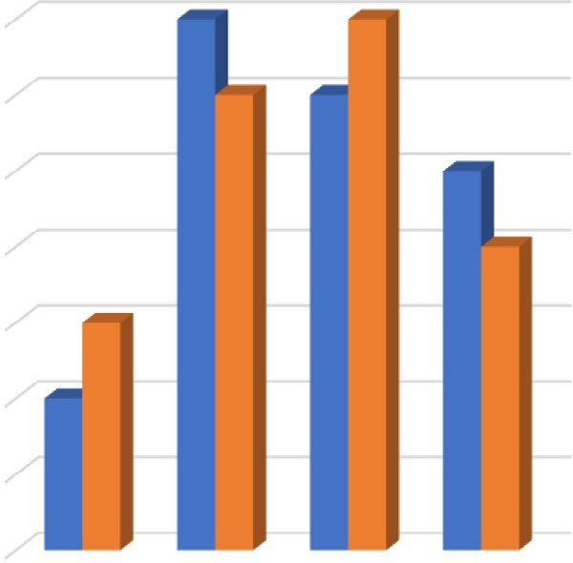Figure 1. A bar chart depicting the distribution of operated disc levels in both patients groups.
Operated Disc Levels in both Groups
7

6

5

4

3

2

1

0
C 3-4 C 4-5 C 5-6 C 6-7
ACDF DCI
Patient No.

Table 2. Radiographic outcome parameters.

Radiographic changes | ACDF (N=20) | DCI (N=20)
Fusion | 20 (100%) | NA
Adjacent level changes | 5 (25%) | 1(5%)
Preserved segmental motion | NA | 17
Fusion across DCI | NA | 2

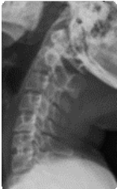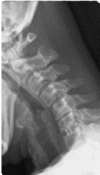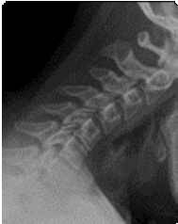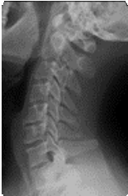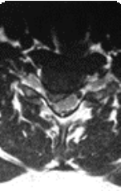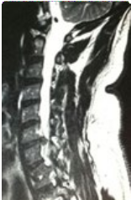
A
B
C
D
E
F
Figure 2. A 39-year-old, female, housewife presenting with neck pain and right brachialgia. Preoperative (A) sagittal T-II WI MRI; (B) axial T-II WI MRI showing C6/C7 paramedian disc hernia. Preoperative plain radiographs: (C) lateral flexion view; (D) extension lateral view. Twenty-four month postoperative radiographs: (E) lateral flexion view; (F) latereal extension view.

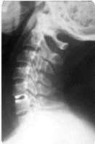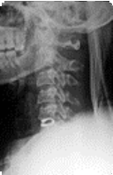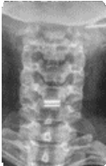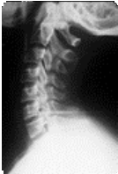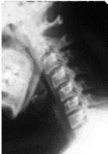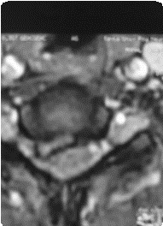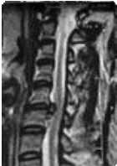
A
B
C
D
E
F
G
Figure 3. A 52-year-old, female, housewife presenting with neck pain and right brachialgia. Preoperative T-II WE MRI: (A) sagittal image; (B) axial iamge showing C5/C6 right paramedian disc hernia. Lateral plain radiographs:
(C) lateral flexion view; (D) lateral extension view. (E) Eighteen-month postoperative anteroposterior view, (F) lateral flexion view, and (G) lateral extension view showing DCI with mobile operated segment with no changes in the adjacent disc level.

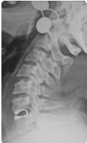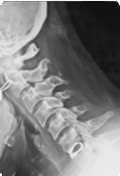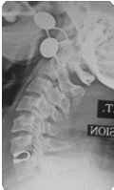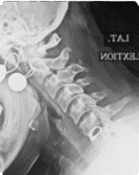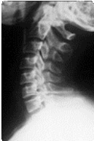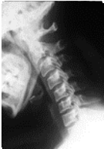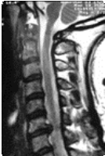
A
B
C
D
E
F
G
Figure 4. A 40-year-old, female, housewife presenting with neck pain and left brachialgia. Preoperative T-II WE MRI: (A) sagittal image showing C6/C7 left disc herniation. Lateral plain radiographs: (B) lateral flexion view;
(C) lateral extension view. Eighteen-month postoperative (D) lateral flexion view, (E) lateral extension, 24-month postoperative (F) lateral flexion view, and (G) lateral extension view showing DCI with mobile operated segment with no changes in the adjacent disc level.

DISCUSSION
ACDF has been considered for a long time to be the gold standard for treating the cervical disc disease. However, concerns regarding symptomatic adjacent segment disease, that needs reoperation, have evolved and necessitate surgeons to try to find another solution that preserves the normal spine motion at the cervical level and avoids this problem.15 Total disc replacement (TDR) or arthroplasty trials started to take place in spine practice, aiming to restore and maintain the segmental motion, function, and normal physiological anatomy, while successfully treating the patient’s symptoms. Heterotopic ossifications and implant-related complications of the TDR itself made the procedure under continuous evaluations. Many types and forms of TDR implants were introduced in the market; none of them fulfill all the criteria of the ideal TDR prosthesis.10 Therefore, the need for an intermediate solution between static fusion and TDR rapidly increases. If the interbody implant can maintain a controlled movement in the affected motion segment, results are supposed to be better and adjacent level disease secondary to fusions is supposed to be delayed. The DCI implant is theoretically supposed to achieve that target. The spring-like flexibility of the Dynamic Cage allows axial displacement and flexion and extension with normal cervical movements. If a great effort is encountered, the self-engagement of the cage can protect the cage slippage to maintain adequate stability. The hollowing of the cage provides a tunnel for bone fusion, while the porous coating on the upper/under surfaces of the cage may promote the expected fusion. Although multilevel DCI has been reported, most surgeons prefer DCI in single-level CDD excluding active infection or displacement more than 5 mm from their inclusion criteria.15
Regarding DCI arthroplasty, it is a procedure that was invented by Dr Matgé in 2002 and then developed and presented to clinical practice by
Paradigm Spine (New York, NY, USA).10 The two main criteria of dynamic cage are being U-shaped with hook teeth at the anterior edge and the axial flexibility. DCI arthroplasty has several advantages: (1) a wide spectrum of indications and being a relatively simple surgical technique7;
(2) a shock absorbing device that limits axial rotation and lateral bending, thus exacerbating facet joint stress12; (3) allowing axial compression in flexion and limited extension, with motion at the index level relatively close to the intact value14;
(4) no friction at the metallic surface when the DCI functions, thus no local or systemic reaction to debris.7
In our study, 40 patients were randomly classified equally into two groups with comparable age and sex distributions and with comparable complaints due to their cervical disc disease. In ACDF group, PEEK cage fusion was utilized; in the DCI group, intervertebral DCI implant. Both groups were followed up clinically and radiologically for comparable periods.
Clinical status of both groups showed significant improvement. Although clinical outcomes between the two groups were not significantly different at final follow-up, radiographic parameters were relatively well maintained in our DCI group compared to our ACDF group.
These results coincide with the results of others. Matgé et al.11 operated on 47 patients with DCI arthroplasty and achieved satisfactory clinical outcomes in 2 years of follow-up; 3 of the 47 patients had implant slippage and 12 patients had major spondylotic changes in the form of heterotopic ossification which ended in decreased range of motion (ROM). Li et al.7 reported that DCI and ACDF had the same effect in improving and maintaining clinical functions, but DCI arthroplasty resulted in a better overall or segmental ROM; no slippage of DCI was detected through the 2-year follow-up. Liu et al.9 stated that patients who underwent operated with total disc replacement had more incidence of heterotopic ossification than those who with DCI arthroplasty through a 2-year follow-up period, but other

parameters were similar, and no DCI subsidence was detected. A contrary view was adopted by Wang et al.23, in their study with a long follow-up period, as they concluded that DCI arthroplasty had a clinical efficacy that was maintained during mid- to long-term follow-up. Heterotopic ossification is evident at final period of follow-up, leading to a significant decrease in ROM at the index level and a potential risk of spinal cord or nerve root compression.
The incidence of implant subsidence and migration after DCI arthroplasty is relatively high, carrying a potential risk of spinal cord injury. Based on their results, they suggest that ACDF should still be the first choice for patients with degenerative cervical disc disease, rather than DCI arthroplasty. Habba et al.3 released a valuable work showing and concluding that ACDF with PEEK cage filled with hydroxy apatite is a safe and effective method to achieve interbody fusion in patients with cervical disc disease, fusion occurred within usual time, and the incidence of sound fusion was relatively high as they reached about 87.9 % (29 out of 33 levels) showing sound bony fusion according to study criteria, while 4 operated disc levels (12.1%) showed nonunion.
Another study done by Mohieldien15 was dedicated only for DCI arthroplasty aimed to study the efficacy and feasibility of the technique in treating single-level CDD; he stated that satisfactory results for neck and radicular pain were achieved by the first postoperative day and deficits had almost cleared by 3 months. Most patients (86.7%, 13/15) lost their neck pain and, at the end, he concluded that arthroplasty can be an easy and effective method to treat cervical degenerative disc disease. In a study by Li et al.7 concentrating on the postoperative range of motion after both DCI and ACDF, they concluded that, in spite of nearly similar improvement in clinical results, in the DCI group, they noticed that ROM is improved in the DCI group for the successive 2 years after surgery and after that period the ROM significantly decreased; thus, he concluded that both techniques
had the same results at the final follow-up period of 5 years noting that DCI cannot decrease the rate of ASD compared to the ACDF.
CONCLUSION
Although clinical outcomes of both ACDF and DCI groups were not significantly different at final follow-up, radiographic parameters were relatively better in DCI group compared to our ACDF group including segmental mobility preservation and adjacent level changes. We recommend future study with a larger sample and longer follow-up period for more assessment of the validity of the DCI and evaluation of its effect on adjacent level pathology.
REFERENCES
- Brodke DS, Zdeblick TA: Modified Smith- Robinson procedure for anterior cervical discectomy and fusion. Spine 17:S427–S430, 1992
- Demircan MN, Kutlay AM, Colak A, Kaya S, Tekin T, Kibici K, et al: Multilevel cervical fusion without plates, screws or autogenous iliac crest bone graft. J Clin. Neurosci 14:723– 728, 2007
- Habba HR, Abou-Madawi AM, Al Qazaz MY, Moustafa MM: Patterns of spinal fusion after anterior cervical discectomy and fusion with polyether ether ketone cage filled with hydroxyapatite. Egy Spine J 29:2–11, 2019
- Kulkarni AG, Hee HT, Wong HK: Solis cage (PEEK) for anterior cervical fusion: preliminary radiological results with emphasis on fusion and subsidence. The Spine J 7:205– 209, 2007
- Landers MR, Addis KA, Longhurst JK, VomSteeg BL, Puentedura EJ, Daubs MD: Anterior cervical decompression and fusion

on neck range of motion, pain, and function: a prospective analysis. Spine J 13:1650–1658, 2013
- Liao JC, Niu CC, Chen WJ, Chen LH: Polyetheretherketone (PEEK) cage filled with cancellous allograft in anterior cervical discectomy and fusion. Int. Orthop 32(5):643– 648, 2008
- Li Z, Yu S, Zhao Y, Hou S, Fu Q, Li F, et al: Clinical and radiologic comparison of dynamic cervical implant arthroplasty versus anterior cervical discectomy and fusion for the treatment of cervical degenerative disc disease. J Clin Neurosci 21(6):942–948, 2014
- Liu JT, Chen WC, Wei HW: Biomechanical evaluation of a dynamic fusion cage design for cervical spine: A finite element study. Advances in Mechanical Engineering 9(5):1– 7, 2017
- Liu SC, Song YM, Liu LM, Wang Lei, Zhou Z, Zhou C, et al: Clinical and radiologic comparison of dynamic cervical implant arthroplasty and cervical total disc replacement for single-level cervical degenerative disc disease. J Clin Neurosci 27:102–109, 2016
- Matgé G: Cervical cage fusion with 5 different implants: 250 cases. Acta Neurochir 44:539- 550, 2002
- Matge’ G, Eif M, Herdmann J: Dynamic cervical implant (DCITM): clinical results from an international multicenter prospective study. Paradig Spine 1:1–3, 2009
- Matge’ G, Berthold C, Gunness VR, Hana A, Hertel F: Stabilization with the dynamic cervical implant: a novel treatment approach following cervical discectomy and decompression. J Neurosurg Spine 22(3):237– 245, 2015
- Matsunaga S, Kabayama S, Yamamoto T, Yone K, Sakou T, Nakanishi, K: Strain on intervertebral discs after anterior cervical decompression and fusion. Spine 24:670–675, 1999
- Mo ZJ, Zhao YB, Wang LZ, Sun Y, Zhang M, Fan YB: Biomechanical effects of cervical arthroplasty with U-shaped disc implant on segmental range of motion and loading of surrounding soft tissue. Eur Spine J 23(3):613– 621, 2014
- Mohi Eldin MM: Dynamic cervical implant (DCI) in single level cervical disc disease. The Open Spine Journal 6:1–8, 2014
- Peppers TA, Bullard DE, Vanichkachorn JS: Prospective clinical and radiographic evaluation of an allogeneic bone matrix containing stem cells (Trinity Evolution® Viable Cellular Bone Matrix) in patients undergoing two-level anterior cervical discectomy and fusion. J Orthop Surg Res 12:67, 2017
- Reitman CA, Hipp JA, Nguyen L, Esses SI: Changes in segmental intervertebral motion adjacent to cervical arthrodesis. A prospective study. Spine 29:E221–E226, 2004
- Schwab JS, Diangelo DJ, Foley KT: Motion compensation associated with single-level cervical fusion: where does the lost motion go? Spine 31(21):2439–2448, 2006
- Shapiro S, Connolly P, Donnaldson J, Abel T: Cadaveric fibula, locking plate, and allogenic bone matrix for anterior cervical fusion after cervical discectomy for radiculopathy or myelopathy. J Neurosurg 95 (Supp 1):43–50, 2001
- Song KJ, Lee KB: A preliminary study of the use of cage and plating for single-segment fusion in degenerative cervical spine disease. J Clin.Neurosci 13:181–187, 2006
- Sugawara T, Itoh Y, Hirano Y, Higashiyama N, Mizoi K: Long term outcome and adjacent disc degeneration after anterior cervical discectomy and fusion with titanium cylindrical cages. Acta Neurochir 151:303–309, 2009

- Topuz K, Çolak A, Kaya S: Two-level contiguous cervical disc disease treated with peek cages packed with demineralized bone matrix: results of 3-year follow-up. Eur Spine J. 18(2): 238–243, 2009
- Wang L, Hu B, Wang L, Song Y, Yang X, Liu L, et al: Clinical and radiographic outcome of dynamic cervical implant (DCI) arthroplasty for degenerative cervical disc disease: a minimal five-year follow-up. BMC Musculoskeletal Disorders 19:101, 2018

الملخص العربي
المقارنـة بيـن نتائـج التدخـل الجراحـي لحـاالت الغضـروف العنقـي ذات المسـتوي الواحـد باسـتخدام القفـص
العنقي والدعامة العنقية الحركية: سريريا وإشعاعيا
البيانات الخلفية: على الرغم من أن األقفاص العنقية الكربونية هي حجر الزاوية في عالج الغضاريف العنقية حتى اآلن إال أن المضاعفـات التـي تحـدث منهـا، ومنهـا علـى سـبيل المثـال فشـل االلتئـام وتزحـزح الدعامـات مـن موضعها مما دفع الباحثين إلى إيجاد حلول بديلة لها ومن أهمها كان الدعامات العنقية الحركية التي تتيح نسبة من الحركة
على المستوي الذي تم إجراء الجراحة به والتي لها نتائج واعدة ومبشرة.
الغـرض: وتهـدف هـذه الدراسـة إلـى المقارنـة بيـن نتائـج التدخـل الجراحـي باسـتخدام األقفـاص العنقيـة الكربونيـة
واألقفـاص الحركيـة فـي المرضـى الذيـن يعانـون مـن انزالقات غضروفية عنقية ضاغطـة ومؤثرة على جذور األعصاب
أو النخاع الشوكي.
تصميم الدراسة: دراسة مقارنة ترقبية لنتائج مجموعتين. المرضى والطرق الدراسة: تم إجراء هذه الدراسة على المرضى الذين يعانون من آالم الرقبة والذراعين نتيجة وجود انزالق غضروفي عنقي على مستوي واحد. وقد تم إجراء هذه الدراسة بقسم جراحة المخ واألعصاب بمستشفيات
جامعـة بنهـا فـي الفتـرة مـن ينايـر عـام 2015 حتـي نهاية مايو عام 2019 وعددهم أربعون مريضا 21 من الذكور و19 مـن اإلنـاث بمتوسـط عمـر 45 ± 8.9 سـنة. تـم تقسـيمهم عشـوائيا لمجموعتيـن: األولـى: 20 مريضـا الذين تم تركيب
أقفاص عنقية كربونية لهم، الثانية: 20 مريضا الذين تم تركيب الدعامات العنيقية الديناميكية لهم.
النتائج: تبين من متابعة المرضي طوال فترة الدراسـة وجود تحسـن في الحالة المرضية في كال المجموعتين حيث أن معامـل الشـعور باأللـم )VAS( ومعـدل إعاقـة الرقبـة )NDI( قـد تحسـنا كثيـرا بعـد الجراحـات. وقـد لوحظ أن معدل التحام الفقرات في المجموعة األولى كان بنسبة 100 في المئة واعتالل المستويات المجاورة بنسبة 25% .بالرغم مـن هـذا تـم مالحظـة أن نتائـج األشـعة المختلفـة في المجموعة الثانية كانـت أفضل من حيث توازن العمود الفقري وحفـظ المسـافة بيـن الفقـرات وعـدم حـدوث مضاعفـات علـى المسـتويات المجـاورة وانخفـاض اعتـالل المسـتويات
المجاورة إلى 5% في حالة استخدام الدعامات العنقية.
االستنتاج: بالرغم من تحسن الحالة المرضية في كال المجموعتين، يعد استخدام الدعامات العنقية الحركية أفضل
مـن األقفـاص العنقيـة الكربونيـة مـن حيـث تقليـل حـدوث تغيـرات أو اعتـالالت مسـتويات الغضاريـف المجـاورة ومـن
حيث حفظ ميكانيكية الحركة على المستوي الذي تم إجراء الجراحة به.

