PREDICTING THE OUTCOME OF MICROSURGICAL RESECTION OF OLFACTORY GROOVE MENINGIOMAS (OGMs): EXPERIENCE AT BENHA UNIVERSITY HOSPITAL
Moataz A. Elawady, MD, Mahmoud M. Wahdan, MD and Mohammed E. Elhawary, MD
Neurosurgery Department – Benha University
ABSTRACT
BACKGROUND: Radical excision of olfactory groove meningioma is the goal of microsurgery but faces some challenges such as the hypersostotic bone and paranasal sinus invasion with resulting cerebrospinal fluid (CSF) leak and infection making high recurrence rate.
AIM AND OBJECTIVES: The aim of the present study was to identify factors predicting the outcome for patients with a diagnosis of OGMs undergoing microsurgical resection and to examine whether there is a general benefit of such microsurgery
PATIENTS AND METHODS: A total number of 28 patients were microsurgically operated for OGMs at the Neurosurgery Department of Benha University Hospital between January 2012 and December 2018
RESULTS: no patient characteristics, such as age, sex or presenting symptoms could be considered predictive for the postoperative outcome. Of the tumor- related characteristics only the presence of skull base invasion and the Simpson grading of removal were considered negative predictors for the outcome.
CONCLUSIONS: Microsurgical removal of the OGMs is effective and save with very little morbidity and low risk of postoperative recurrence provided that it is done totally with complete reconstruction of the skull base.
Keywords: OGMs – microsurgery – skull base
Meningioma comprises 13 – 30 % of all intracranial neoplasms ^{11,14}. Olfactory groove meningioma (OGM) is not uncommon location representing between 4 to 10 % of such tumors and arise in the midline over the cribriform plate and frontosphenoidal suture between the crista galli and the tuberculum sellae ⁴. OGMs attain large size before being symptomatic in the form of mental changes and visual field defects making late diagnosis is the role ^{2,14}.
Radical excision of OGMs is the goal of microsurgery but faces some challenges such as the hypersostotic bone and paranasal sinus invasion with resulting cerebrospinal fluid (CSF) leak and infection making high recurrence rate 5- 41 % ¹⁴.
The aim of the present study was to identify factors predicting the outcome for patients with a diagnosis of OGMs undergoing microsurgical resection and to examine whether there is a general benefit of such microsurgery
PATIENTS AND METHODS
Study design: This is a retrospective single centre analytical study of all patients who was microsurgically operated for OGMs at the Neurosurgery Department of Benha University Hospital between January 2012 and December 2018
Patients: A total number of 28 patients were microsurgically operated for OGMs at the Neurosurgery Department of Benha University Hospital between January 2012 and December 2018
Preoperative work: For all patients, demographic data were obtained regarding age, sex, residence, marital status and comorbidities. Complete general and neuro-ophthalmological examination and investigations such as brain magnetic resonance imaging (MRI) and computed tomography (CT) of the paranasal sinuses were obtained for all patients. Any patient with visual complain was examined by an expert ophthalmologist regarding the fundus and visual field. Preoperative Kanofsky Performance Score was accurately measured and recorded for each patient.
According to size tumors were classified as small when tumor size on MRI was less than 2 cc, medium with 2-4 cc tumor size, large with 4-6 cc tumor size and giant when tumor size exceeds 6 cc.
Operative details: The bilateral subfrontal approach was done for16 patients when the tumor was sizable and the unilateral subfrontal approach was done for the small- to- medium12 tumors ⁵
- Patient position: The patient is placed in the supine position on the operating table with the head fixed in a three-pin Mayfield headholder. The patient’s neck is retroflected, resulting in an angle of approximately 20° between the plane of the anterior cranial base and the vertical plane of the axis. This position allows the frontal lobe to fall away from the anterior cranial floor and facilitates good venous drainage during surgery. Fine adjustments of the patient’s position are accomplished by tilting the operating table.
- Skin incision: After a precise definition of the frontal anatomic landmarks (e.g., the orbital rim, supraorbital foramen, temporal line and zygomatic arch), the line of the incision is marked on the skin. Thereafter the skin is prepared with Betadine solution. The skin incision, usually placed behind the hairline, begins less than 1 cm anteriorly to the tragus on the side of the craniotomy and extends medially in a curvilinear fashion above the superior temporal line, slightly crossing the midline by 1 or 2 cm in unilateral incision or to the opposite tragus in bilateral incisions. As the skin is reflected anteriorly along with the pericranium and retracted with temporary fishhooks, the galea will merge with the superficial layer of the temporalis fascia. At the supraorbital ridge, care should be taken to identify and preserve the supraorbital nerve and the supraorbital artery passing along the medial third of the superior orbital rim. Upon retraction of the skin-aponeurosis flap, a semilunar incision is made through the pericranium under the frontozygomatic process, 0.5cm superior to the temporal line and diagonally along he frontal lobe. At this point the pericranium is separated from the inferior surface of the frontozygomatic process and reflected. Careful dissection and minimal retraction of the orbicular and frontal muscular layer are essential to avoid a postoperative periorbital hematoma. Before starting the craniotomy local hemostasis must be performed.
- Craniotomy: The craniotomy is started using a high-speed drill, with the placement of a single frontobasal burr hole at MacCarty’s point, posterior to the temporal line, just above the frontosphenoid suture or at the frontozygomatic point. This is the keyhole that represents an anatomic window that provides access to the anterior cranial base. A high-speed craniotome is then used to create the bone flap, which must extend anteriorly to the origin of the frontozygomatic process and parallel to the temporal line. The craniotome is directed from the first hole superiorly and describes a curve in the frontal area. The limits are the supraorbital foramen medially and the sphenoid wing laterally. The lateral border of the frontal sinus has to be considered during craniotomy. Continuous irrigation during the drilling avoids thermal damage to the brain and allows more precise bone cutting. A hand-held retractors is used to provide the necessary soft-tissue retraction and exposure as the craniotome is turned around the flap. If dissection of the dura cannot be easily accomplished from a single burr hole, then a second burr hole can be made. Careful separation of the dura from the inner surface of the bone using a blunt dissector avoids laceration of the dura mater. An important next step is the drilling of the inner edge of the orbital roof protuberances with a highspeed drill (unroofing) to optimize the exposure to the anterior cranial fossa and the angle to reach the frontobasal area.
- Dural opening: Typically, the dura is opened in a C-shaped fashion, under the operating microscope, with its base toward the cranial base, parallel along the orbital floor. It is reflected anteriorly and anchored with stay sutures. A clearance of several millimeters should be allowed between the bone margin and the dural incision, to facilitate the final closure of the dura. When it is reflected, special attention should be paid in the proximity of the superior sagittal sinus. Elevation and retraction of the frontal lobe pole will subsequently expose the target area at the frontal base of the skull.
- Tumor removal: The arachnoid is slightly incised with an arachnoidal hook, or as an alternative, bipolar forceps could be used to make a hole in the arachnoid membrane. It is important to follow the arachnoid plane using the microforceps and the suction tip to achieve a stepwise dissection until the lesion is reached. During these surgical maneuvers, when a certain degree of brain retraction is needed, a self-retaining brain retractor attached to a flexible arm permits fine adjustment, preserving the normal tissue. Hemostasis must be accurately controlled during the intracranial procedure, and the intradural space should be filled with Ringer’s solution at body temperature. Sometimes the unilateral subfrontal approach could be used for some asymmetric midline lesions with the possibility of cutting the falx above the crista galli and saving the superior sagittal sinus to gain access also to the contralateral side. After the lesion has been managed, the dural incision is sutured water-tight using continuous sutures. The bone flap is appositioned medially and frontally without bony distance to achieve the optimal cosmetic outcome and fixed with low-profile titanium plates and screws.
- Closure: After final verification of hemostasis, the galea with the subcutaneous layers are reapproximated with several interrupted absorbable sutures and the skin is closed with a Donati suture. At the end of the procedure the Mayfield pin headrest is removed and general anesthesia is reversed.
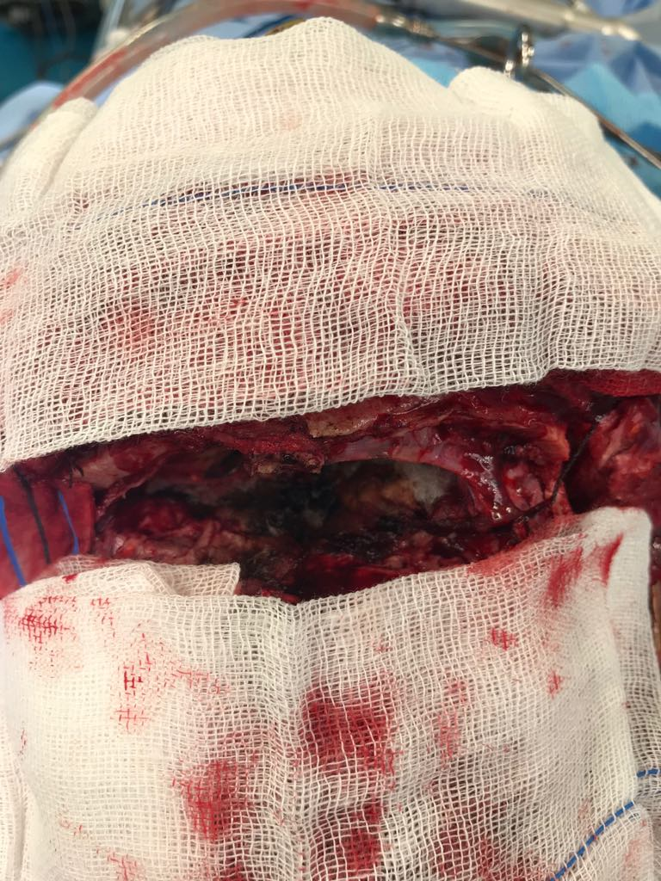
Fig. 1: Intraoperative photograh of bilateral subfrontal approach to remove OGM
Hospital stay: For all patients at least 48 hours of postoperative inpatient care was the r;le and it could be extended thereafter according to the early postoperative course.
Follow up: patients with at least 6-month postoperative follow up were included in this study. Follow up visits were arranged to be weekly in the first month and monthly thereafter. In each visit complete general and neuroophthalmological examination were done. Postoperative MRI study was obtained at the end of 6- month follow up and yearly thereafter.
RESULTS
A total number of 28 patients were microsurgically operated for OGMs at the Neurosurgery Department of Benha University Hospital between January 2012 and December 2018. Out of them, there were 17 females and 11 males with age ranging between 33 and 70 years. In 26 patients De Novo OGMs were encountered in 2 cases, there were recurrent OGMs
Table 1: patient criteria
patient | sex | age | Presenting symptoms | type | size | Simpson’s grading | WHO grade | Histological type | Follow up (months) | outcome
1 | F | 33 | Seiyures/ headache | De Novo | large | I | I | Meningiothelial | 12 | Good
2 | F | 55 | Seizures/ blurred vision | De Novo | small | I | I | Transitional | 18 | Good
3 | M | 65 | Seiyures/ headache | De Novo | small | I | I | Fibroblastic | 10 | Good
4 | F | 45 | Seizures/ blurred vision | De Novo | medium | I | I | fibroblastic | 16 | Good
5 | F | 50 | Seiyures/ headache | De Novo | large | II | I | Meningiothelial | 9 | Good
6 | F | 52 | Blurred vision | De Novo | medium | II | III | Transitional | 24 | Blurred vision
7 | M | 70 | Seiyures/ headache | De Novo | large | II | II | Fibroblastic | 12 | Blurred vision
8 | M | 58 | Blurred vision | De Novo | large | I | I | Transitional | 12 | good
9 | F | 42 | Seiyures/ headache | De Novo | giant | II | I | Psamomatous | 6 | Good
10 | F | 35 | Seizures/ blurred vision | De Novo | giant | II | II | Fibroblastic | 24 | Blurred vision
11 | F | 38 | Seiyures/ headache | De Novo | large | II | I | Meningiothelial | 36 | Good
12 | M | 57 | Accidentally discovered | De Novo | large | I | I | Transitional | 9 | Good
13 | F | 37 | Accidentally discovered | De Novo | medium | II | I | Psamomatous | 10 | Good
14 | M | 57 | Blurred vision | De Novo | small | II | III | Transitional | 12 | Blurred vision
15 | M | 52 | Seiyures/ headache | De Novo | large | II | I | Fibroblastic | 12 | Good
16 | F | 40 | Seiyures/ headache | De Novo | giant | II | II | Transitional | 12 | recurrence
17 | M | 45 | Seiyures/ headache | De Novo | large | I | I | Meningiothelial | 18 | Good
18 | F | 42 | Seizures/ blurred vision | De Novo | small | II | I | Transitional | 18 | Blurred vision
19 | F | 44 | Seiyures/ headache | De Novo | large | II | I | Fibroblastic | 20 | Good
20 | M | 46 | Accidentally discovered | De Novo | large | II | I | Transitional | 22 | Good
21 | F | 37 | Seiyures/ headache | De Novo | medium | II | I | Fibroblastic | 20 | Blurred vision
22 | M | 39 | Blurred vision | De Novo | medium | I | I | Transitional | 12 | Good
23 | F | 40 | Blurred vision | De Novo | giant | II | II | Fibroblastic | 15 | recurrence
24 | M | 42 | Seizures/ blurred vision | De Novo | small | II | I | Meningiothelial | 14 | Blurred vision
25 | F | 41 | Seiyures/ headache | De Novo | large | II | I | Fibroblastic | 14 | Good
26 | F | 45 | Seiyures/ headache | De Novo | large | II | I | Meningiothelial | 12 | Good
27 | F | 41 | Seiyures | recurrent | small | 1I | I | Fibroblastic | 8 | Good
28 | F | 41 | Seiyures/ headache | recurrent | small | II | I | Transitional | 6 | Good

Table 2: presenting symptoms in our patients
symptom | Number of patients (%)
Seizures | 21 (75)
Headache | 14 (50)
Blurred vision | 10 (35.7)
No symptom | 3 (10.7)
According to tumor size, 7 tumors were small, 5 were medium, 12 were large and 4 were giant. Histological types of the tumors were transitional in 10 patients, fibroblastic in 10 patients, meningiothelial in 6 patients and psamomatous in 2 patients. WHO grading of the tumors was grade I in 21 patients, grade II in 5 patients and grade III in 2 patients
Table 3: Simpson’s grading system
Grade | Definition of corresponding resection | Number of patients
I | Macroscopically complete resection with excision of dural attachment and abnormal bone | 5
II | Macroscopically complete resection with coagulation of dural attachment | 21
III | Macroscopically complete resection without resection or coagulation of its attachment | 0
IV | Subtotal resection | 0
V | Simple decompression of the tumor | 0
Simpson Grade I resection was achieved in 10 cases and grade II in 18 cases. No death occurred. Cerebrospinal fluid rhinorrhea occurred in two patients and responded to 2 weeks of conservative treatment in the form of elevated head position , acetazolamide and temporary lumbar drain. No cases needed revision reconstruction surgery, There were no intracranial infection occurred postoperatively. Tumor recurrence was observed in two patients after a followup of 14.75±6.48 (6-36) months with grade II Simpson and when revised microsurgically, grade I was achieved and no further tumor recurrence after 6 and 8 months followup.
a- b-
c- d-
Fig. 2: MRI images a- preop axial, b- preop coronal, c- preop sagittal and d- postoperative sagittal of OGM

DISCUSSION
Meningiomas that compress the frontal lobes , as OGMs are mostly “silent,” and are thus likely to be misdiagnosed or overlooked ¹⁴.
There are several studies that describe in detail the clinical findings, types of neurosurgical approaches, results and rate of recurrences. The most comprehensive studieswere those of Solero et al., 1983 with 98 cases¹⁶, the study of Spektor et al., 2005¹⁷, with 80 patients, the study of Nakamura et al., 2007, 82 cases¹²; the study of Bassiouni et al., 2007, 56 cases³ and the study of Romani et al., 2009 with 66 cases.¹⁵
We used the subfrontal approach either the unilateral (in 12 patients) or the bilateral (in 16 patients) according to the size of tumor on preoperative MRI. The frontolateral approach could be also an option. it allows a good visualization of the optic nerves, chiasm and anterior cerebral arteries and doesn't require a prolonged retraction of the frontal lobe.⁶
Postoperative mortality reached 22% and morbidity to 25% in some seies.^{1, 4} In our study, no death occurred. Cerebrospinal fluid rhinorrhea occurred in only two patients. Recurrence rate ranged from 0 to 10%. The recurrence may reflect incomplete resection of the tumor due to the difficulties in resection or be the result of ethmoidal bone invasion with incomplete removal of infiltrated bone. Only 2 of our denovo 26 patients showed recurrence but according to Obeid and Al-Mefty, the OGM could have a high rate of late recurrence (average 23%).¹³
Although L iu et al., 2007 and Liang et al., 2011 stated that Radical excision of OGMs (Simpson grade I) should be the goal of microsurgery, this is not always feasible.^{9, 10}
In our study, no patient characteristics, such as age, sex or presenting symptoms could be considered predictive for the postoperative outcome. Of the tumor- related characteristics only the presence of skull base invasion and the Simpson grading of removal were considered negative predictors for the outcome.
These results are in accord with those of others who studied the prognostic factors of microsurgical treatment of meningiomas in general.^{7, 8}
Recently, it has been shown that the Simpson grade is not universally applicable to all meningiomas. So, there has been a trend towards more conservative treatment for meningiomas, mainly, a staged treatment with debulking followed by adjuvant treatment might be preferable in order to minimize postoperative morbidity and mortality, especially in skull-base meningiomas.⁸ The predictive factors of poor outcome identified in this study may help neurosurgeons to identify those patients who may fare better with staged treatment
CONCLUSIONS
Microsurgical removal of the OGMs is effective and save with very little morbidity and low risk of postoperative recurrence provided that it is done totally with complete reconstruction of the skull base.
REFERENCES
- Aguiar PH, Tahara A and Almeida AN et al. (2009): Olfactory groove meningiomas: approaches and complications. J Clin Neurosci 16(9):1168–1173
- Babu R, Barton A and Kasoff SS (1995): Resection of olfactory groove meningiomas: Technical note revisited. Surg Neurol.; 44:567–72.
- Bassiouni H, Asgari S, Stolke D (2007) Olfactory groove meningiomas: functional outcome in a series treated microsurgically. Acta Neurochir (Wien) 149(2):109–121
- Ciurea AV, Iencean SM and Rizea RE et al. (2012): Olfactory groove meningiomas. Neurosurgical Review, Volume 35, Issue 2, pp 195–202.
- De Divitiis O, Iacopino DG and Solari D et al. (2010)
Subfrontal Approaches. In: Cranial, Craniofacial and Skull Base Surgery. Cappabianca P • Califano L Iaconetta G (Ed.): Springer,2, 17-27.
- El-Bahy K (2009) Validity of the frontolateral approach as a minimally invasive corridor for olfactory groove meningiomas. Acta Neurochir (Wien) 151(10):1197–1205
- Fernandez C, Nicholas MK and Engelhard HH et al.( 2016): An analysis of prognostic factors associated with recurrence in the treatment of atypical meningiomas. Adv Radiat Oncol.;1:89–93.
- Lemée JM, Corniola MV and Da Broi M et al. (2019): Extent of Resection in Meningioma: Predictive Factors and Clinical Implications. Sci Rep.; 9: 5944.

Liang RS, Zhou LF and Mao Y et al. (2011): Microsurgical removal of olfactory groove meningiomas. Zhonghua Zhong Liu Za Zhi. Jan;33(1):70-5.
- Liu Y, Liu M and Chen Y et al.( 2007): Microsurgical total removal of olfactory groove meningiomas and reconstruction of the invaded skull bases. Int Surg. May-Jun;92(3):167-73.
- Maurice-Williams RS and Dunwoody G (1988): Late diagnosis of frontal meningiomas presenting with psychiatric symptoms. Br Med J (Clin Res Ed);296:1785–6.
- Nakamura M, Struck M, Roser F, Vorkapic P, Samii M (2007) Olfactory groove meningiomas: clinical outcome and recurrence rates after tumor removal through the frontolateral and bifrontal approach. Neurosurgery 60(5):844–852
- Obeid F, Al-Mefty O (2003) Recurrence of olfactory groove meningiomas. Neurosurgery 53:534–543
- Ravikanth R, Pinto D S, and Mathew S (2018): Olfactory groove meningioma masquerading as psychiatric disturbances. Indian J Psychiatry. Jul-Sep; 60(3): 367–369.
- Romani R, Lehecka M and Gaal E et al., (2009): Lateral supraorbital approach applied to olfactory groove meningiomas: experience with 66 consecutive patients. Neurosurgery 65(1):39–52
- Solero CL, Giombini S and Morello G (1983) Suprasellar and olfactory meningiomas. Report on a series of 153 personal cases. Acta Neurochir (Wien) 67:181–194
- Spektor S, Valarezo J and Fliss DM et al., (2005): Olfactory groove meningiomas from neurosurgical and ear, nose, and throat perspectives: approaches, techniques, and outcomes. Neurosurgery 57(4 Suppl):268–280

الملخص العربي

التنبؤ بناتج الاستئصال الميكرسكوبي للاورام السحائية بالممر الشمي: خبرة مستشفي بنها الجامعي

الخلفية العلمية: ان الاستئصال الجذري للاورام السحائية بالممر الشمي هو الهدف من الجراحة الميكروسكوبية ولكن فد يعترض ذلك وجود تضخم عظمي او اجتياح للجيوب الجار-انفية وما يتبعه من تسرب للسائل النخاعي الشوكي والعدوي التي تزيد من نسبة ارتجاع مثل هذه الاورام.

الهدف من الدراسة:تهدف هذه الدراسة الي محاولة ايجاد العوامل التي تتنبأ بناتج الاستئصال الميكرسكوبي للاورام السحائية بالممر الشمي و عما اذا كانت توجد فائدة لهذه الجراحة بصورة عامة.

المرضي ووسائل البحث:أجريت هذه الدراسة في مستشفي بنها الجامعي علي 28 مريض اجريت لهم جراحة ميكروسكوبية لاستئصال ورم سحائي بالممر الشمي في الفترة من يناير 2012 وحتي ديسمبر 2018.

النتائج:لم يتم ربط اي من العوامل الخاصة بالمريض مثل العمر او الجنوسة او الاعراض المصاحبة كعوامل تنبؤية ومن العوامل الخاصة بالورم تم ربط درجة اجتياح عظام قاع الجمجمة ودرجة استئصال الورم كعوامل سلبية للناتج الجراحي

الخلاصة:للجراحة الميكروسكوبية دور فعال في استئصال الاورام السحائية بالممر الشمي اذا ما امكن استئصال الورم تماما مع اعادة تشكيل قاع الجمجمة لتحنب نسبة الارتجاع العالية.

