Curriculum Vitae (C.V.)
- Personal data:
Name (Arabic) | محمد عبد الرازق مصطفي منصور
Name (English) | Mohamed abdelrazik mustafa mansour
Department | Anesthesiology, surgical icu and pain medicine
College | Faculty of medicine- banha university
Academic degree | Master degree
Office Address | Banha university hospital- banha -Qalubya
Mobile 1 | 01022708985
Home phone | -
Email (university) | Mohamed.abdelrazik21@fmed.bu.edu.eg
Email (alternative) | Mhmdabdelrazik248@gmail.com
Web site (if any) | -
Recent Photo (passport format) | 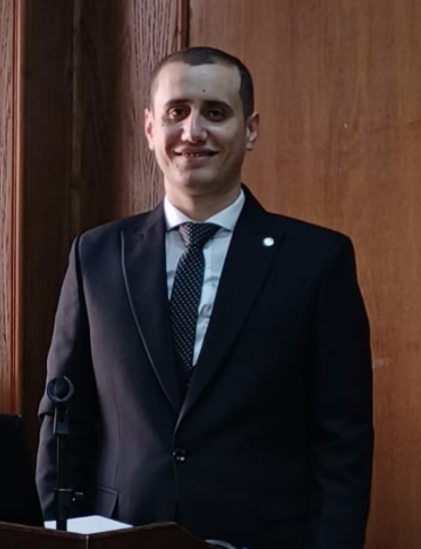

- Education:
2.A. Degree obtained;
Institution | Degree obtained | Year
Faculty of medicine- banha university | MBBS | 2018
Faculty of medicine- banha university | Masters degree of anesthesiology and surgical icu | 2023

2.B. Specialty;
General specialty. | Anesthesiology
Specific specialty. | -

2.C. Language skills (Excellent, Very Good, Good or Basic);
Language | Reading | Speaking | Writing
Arabic. | Native | Native | Native
English. | Excellent | Excellent | Excellent
French. | - | - | -
Other (germany). | -basic | - basic | - basic

- Positions:
Tittle | Year | University/Institution
Resident in anesthesia department | 2019-2022 | Banha university hospital
Assistant lecturer in anesthesia department | 2022-present | Banha university hospital

- Cooperation with local and international entities having website:
( جامعة – مؤسسة - وزارة – مركز بحثي – عضو هيئة تدريس – باحث - شركة – مصنع – الخ)
Name of local and international entity | Website
- Membership of professional bodies (List):

- Membership of institute (List):

- Distinction and Awards (List):

- Academic:
Courses at under graduate level;
1. Course name: | Clinical rounds;
2. Course name: | Lectures;
Courses at post graduate level;
- اخلاقيات البحث العلمي | - مهارات التواصل الفعال
- منهجية اللحث العلمي | - مهارات العرض الفعال
- مهارات التواصل الفعال | - ادارة الوقت وضغوط العمل
- تحليل البيانات | - معايير الجودة في العملية التدريبية
- التحول الرقمي
- Areas of research:
-Anethesia
-intensive care medicine
-pain medicine
- PhD/M.Sc Supervision:
Title | PhD/M.Sc | Year completed / in progress
Post operative delirium in geriatric patients | M.Sc | 2023

- Grants for Projects:
Funding organization | Project title | Role | Year
- Committees:
-
- List of Publications:
- Benha Journal of Applied Sciences (BJAS)
14. Attended Workshops, Symposiums, and Conferences: "List name and year";

Name of Workshops, Symposiums, and Conferences | Year
Regional Anesthesia Workshop | 2023
eFAST Ultrasonography Workshop | 2023
Mechanical Ventilation Workshop | 2023
1nd annual Benha intensive care conference | 2022
10th ANNUAL MEDICAL CONFERENCE STRATEGIC PLANNING IN MEDICINE, 2020- 2023 "GATE TO THE FUTURE" | 2023

- Books published:
-
16. Positions:
 | Date | Organization | Country | Position
1 | - | - | - | -

17. Activities in faculty/university/community service:
Name of Activity service | Year
- Teaching (Rounds and lectures). | -
- Clinical meeting. | -
- Making conferences. | -
- Medical Convoys. | -
- Workshops.
18. Consulting Experience (if any):
-
19. Additional information you would like to put on the website:
-

